Health Care Compliance Association
2017 Compliance Institute

Recent Developments
Under the Federal False Claims Act

March 2017

John T. Boese
Fried, Frank, Harris, Shriver & Jacobson LLP
Washington, D.C.
(202) 639-7220
E-mail: John.Boese@FriedFrank.com

John T. Boese is Of Counsel in the Washington, D.C. office of Fried, Frank, Harris, Shriver & Jacobson LLP, where he was a partner for over thirty years. He continues to represent a broad spectrum of defendants in civil, criminal, debarment, and exclusion cases arising from federal fraud investigations of government contractors and grantees, health care providers, and other organizations. Mr. Boese is the author of the treatise Civil False Claims and Qui Tam Actions (Wolters Kluwer Law & Business) (4th ed. & Supp. 2017-1). It is routinely cited by courts at all levels on issues arising under the civil False Claims Act. The statements herein do not necessarily present the position of the author’s Firm or clients of the Firm, and should not be imputed to them.

© Copyright Fried, Frank, Harris, Shriver & Jacobson LLP
2017

INTRODUCTION

The False Claims Act (“FCA”) was enacted in 1863 in response to allegations of fraud that arose in the context of Civil War procurements, but the FCA became a significant enforcement tool only after Congress enacted watershed amendments in 1986, including stiffer damages and penalties, and the expansion of the rights of private citizens, known as qui tam relators, to bring suits on behalf of the government. The Department of Justice recovered more than $4.7 billion under the FCA in fiscal year 2016, bringing total FCA recoveries to more than $53 billion since 1986. Nearly $3 billion recovered in 2016 was in qui tam cases initiated or brought by relators, whose “relator’s share” totaled $519.6 million that year. The number of qui tam suits filed in fiscal year 2016 was 702, roughly five times the number of non-qui tam suits that the government filed that year. There are no signs that qui tam actions are going to decline.

The Affordable Care Act strengthened the government’s focus on health care fraud, allocating an additional $350 million to that effort over the next ten years, but the single most effective weapon in the government’s arsenal continues to be the civil False Claims Act. Of the $4.7 billion in FCA recoveries in 2016, nearly $2.6 billion was from the health care industry (broadly defined to include pharmaceutical and medical device companies). As the Justice Department has noted, the government’s focus on healthcare-related actions has consistently produced large FCA recoveries. Increasingly, DOJ is demanding “nonmonetary remedial measures,” such as expensive corporate integrity agreements, in FCA settlements. Also, DOJ has announced that it intends to follow the new policy memorandum known as the “Yates Memo” that takes a more aggressive approach toward pursuing individuals as FCA defendants in addition to corporations.

Substantive areas of particular concern to health care providers and the health care industry include upcoding, off-label promotion, failure to document patient care, deficient compliance training, worthless services, and the expanded use of the Antikickback statute as bases for FCA liability. In addition, the knowing nonpayment of an “obligation”—defined to include “knowingly and improperly” retaining an “overpayment” from a government health care program—is a basis for the FCA’s treble damages and penalties under the “reverse false claim” theory of liability. Provisions linking the FCA to government health care program requirements ensure that the FCA’s role in health care fraud enforcement will only increase.

Substantive and procedural FCA amendments enacted in 2009 and 2010―in the Fraud Enforcement and Recovery Act of 2009 (“FERA”), the Affordable Care Act (“ACA”), and the Dodd-Frank Wall Street Reform and Consumer Protection Act (“Dodd-Frank”)―make it easier for the government and qui tam relators to conduct investigations and obtain recoveries under the FCA. The full impact of FERA’s and the ACA’s amendments is now being felt, and it is clear that these amendments will be the basis for attempts to recover more funds, cover more potential defendants, and narrow defenses to FCA suits in the years to come. Now that twenty-nine states plus the District of Columbia, New York City, Chicago, and Philadelphia have false claims laws, false claims litigation often takes place at the federal, state, multi-state, and municipal levels. The considerable resources of the government—federal and state—coupled with the seemingly limitless supply of whistleblowers willing to litigate FCA claims on behalf of the government, assure that the civil False Claims Act will remain one of the government’s most powerful weapons against fraud.

The key changes under FERA, the ACA, and Dodd-Frank discussed below are:

- FERA’s amendments to FCA liability
- FERA’s amendments to the FCA’s procedural provisions
- FERA’s retroactive application to pending FCA cases
- The ACA’s amendments to the “public disclosure” bar
- The Dodd-Frank Act’s amendments to the FCA’s whistleblower provisions.

Important recent FCA developments discussed include:

- Materiality and false certification liability after the Supreme Court’s Escobar decision
- Falsity
- Causation
- The FCA’s knowledge and intent standards—including Escobar’s scienter requirement
- Reverse false claims
- Damages and penalties
- Public disclosure and first-to-file
- Retaliation

For a full discussion of the FCA and decisional law under it, please refer to John T. Boese, Civil False Claims and Qui Tam Actions (Wolters Kluwer Law & Business) (4th ed. & Supp. 2017-1) (“BOESE”). A redline showing the current FCA, as amended, is attached as Appendix 1.

A. FCA Fundamentals

Some important features that are present in both versions of the FCA―before and after FERA―should be noted at the outset:

- Violations of the FCA give rise to potentially enormous economic liability. The law provides that all damages are trebled. Each false claim submitted is subject to a mandatory penalty of $5,500 and $11,000 per violation.

- The FCA can be enforced not only by the powerful resources of the federal government, but also through the use of private plaintiffs, referred to as qui tam relators. The term "qui tam" is derived from a Latin phrase, "qui tam pro domino rege quam pro se ipso," or “who pursues this action on our Lord the King’s behalf as well as his own.” As this phrase indicates, the qui tam action arose in early English common law as a device for permitting private individuals to litigate claims on the sovereign's behalf. Like relators in modern FCA actions, early qui tam litigants not only gained standing they otherwise would lack, but also a share of any recovery obtained on the sovereign's behalf as a result of the qui tam action. Significant amendments to the False Claims Act in 1986 strengthened the rights of relators, and increased the bounties that may be awarded to successful relators, thus dramatically increasing the incentives to filing suit. There are unique procedural steps involved when a qui tam relator initiates FCA litigation, including the requirement that the complaint must be filed under seal, and the United States may intervene and take over the action.

- Whether an FCA suit is initiated by the government or by a qui tam relator, the liability, damages and penalties provisions remain the same. Defendants are also liable for the attorneys' fees and costs of relators.

- A number of state and local governments have adopted their own versions of false claims acts, with qui tam enforcement. Although in the past these laws have varied considerably from the federal FCA, most of them no longer do because they must follow the federal model in order to receive an economic incentive under the Deficit Reduction Act of 2005.

It is also important to note what the False Claims Act does not cover. Although false tax returns are almost certainly the most common false claim filed with the federal government, the False Claims Act expressly excludes such claims from the scope of its coverage. This FCA “tax bar” has been held to apply broadly whenever a false claim is made or a benefit is procured under the Internal Revenue Code, and is not limited to false income tax claims. Recently, however, New York amended its state FCA to allow qui tam enforcement of tax law violations.

B. The 1986 Law

Prior to the 2009 and 2010 amendments, liability under the civil False Claims Act has arisen primarily under the provisions of 31 U.S.C. §§ 3729(a)(1) - (7). The government (or the qui tam relator) bears the burden of proving each element of a False Claims Act violation, including damages, by the preponderance of the evidence. The four most commonly-invoked liability provisions of the 1986 FCA are:

- Section 3729(a)(1) establishes liability for so-called “direct” false claims to the government;

- Section 3729(a)(2) imposes liability for making false records or false statements to support a false claim;

- Section 3729(a)(3) involves conspiracy to get a false claim paid; and

- Section 3729(a)(7), the so-called “reverse false claims provision,” imposes liability for false records or statements made to reduce or avoid an obligation to the government.

The remaining three subsections of Section 3729(a), subsections (a)(4), (a)(5) and (a)(6), tend to be either redundant or to apply to situations that occur infrequently under modern government contracting procedures. These sections of the FCA are seldom invoked, and therefore have not been the subject of significant case law analysis.

The 1986 amendments lowered the intent needed for an FCA violation to the “recklessness” standard, established the burden of proof at a preponderance of the evidence, and expanded the qui tam enforcement mechanism by:

- increasing the relators’ share to up to 30 % of the government’s recovery;
- removing the government knowledge bar and replacing it with public disclosure/original source provisions;
- adding a retaliation provision;
- allowing qui tam participation after U.S. intervention; and
- encouraging qui tam intervention if the U.S. declined to intervene.

C. The 2009 Amendments―FERA
Although Congress stated that its purpose in enacting FERA was to expand the FCA’s liability provisions in order to reach frauds by financial institutions and other recipients of TARP and economic stimulus funds, the 2009 amendments were not needed for that purpose because financial institutions and stimulus funds were already covered by the existing FCA. FERA was simply the vehicle for FCA amendments that had been languishing in Congress since well before the financial crisis in 2008. The broader purpose of a general expansion of the FCA is reflected in the amendments: they are not limited to mortgage and financial fraud, they have nothing to do with financial markets, and they apply across the board to all recipients and payers of government money or property, including health care providers and the health care industry.

The amendments expand FCA liability beyond previous limits by revising all seven of the statute’s liability provisions and redefining key terms such as “claim,” “material,” and “obligation.” While the key liability provisions of the FCA remain those addressing false claims, false statements supporting false claims, conspiracy, and reverse false claims, FERA renumbered and expanded these provisions to cover additional conduct. The new Sections 3729(a)(1)(A), (a)(1)(B), (a)(1)(C), and (a)(1)(G), extend liability to any person who:

- knowingly presents, or causes to be presented, a false or fraudulent claim for payment or approval;
(B) knowingly makes, uses, or causes to be made or used, a false record or statement material to a false or fraudulent claim;
(C) conspires to commit a violation of subparagraph (A), (B), (D), (E), (F), or (G);

[ . . . ] or
(G) knowingly makes, uses, or causes to be made or used, a false record or statement material to an obligation to pay or transmit money or property to the Government, or knowingly conceals or knowingly and improperly avoids or decreases an obligation to pay or transmit money or property to the Government.

A red-line version of the False Claims act is attached as Appendix 1, and use of this red-line is critical to understanding the revisions. Many of the important details of the 2009 amendments are discussed in a contemporaneously issued FraudMail Alert (attached as Appendix 2). A few key illustrations of the expansion in FCA liability under FERA include the following:

- Section 3729(a)(1)(B) amended Section 3729(a)(2) to remove the phrase “to get,” on which the unanimous Supreme Court relied in Allison Engine Co. v. United States ex rel. Sanders to limit FCA liability to false statements or claims made by defendants for the purpose of getting the government to pay the claim. FERA expressly applied this amendment retroactively to “claims” pending on or after June 7, 2008 (which was two days before the Supreme Court’s decision in Allison Engine). This attempt to apply the amendment retroactively to prior conduct has been challenged, and courts are divided on its retroactive application in pending cases.

- The language in Section 3729(a)(3) had been properly interpreted to limit liability for conspiracy to violations of then-Section 3729(a)(1). Section 3729(a)(1)(C) amended this provision to extend liability for conspiracy to commit a violation of any other substantive section of the FCA.

- Section 3729(a)(1)(G) expanded the scope of reverse false claims liability in the prior law under Section 3729(a)(7) to include retention of an overpayment.

More key changes to FCA liability are included in FERA’s statutory definitions of “claim,” “obligation,” and “material” in Section 3729(b), which are discussed below.

The Department of Justice has authority to conduct broad pre-intervention discovery through civil investigative demands (“CIDs”) that allow it to demand production of documents, oral testimony, and answers to interrogatories. This CID discovery power augments DOJ’s pre-existing power to obtain documentary evidence through subpoenas and authorized investigative demands, and it is stronger than standard civil discovery because the Federal Rules of Civil Procedure do not apply to it. FERA expanded DOJ’s power to issue CIDs and to use the information received in response to CIDs for an “official use.” Under this expanded authority, the Attorney General’s authority to issue CIDs was delegated to the Assistant Attorney General for the Civil Division, who then redelegated this authority to certain senior enforcement officials in the Civil Division as well as to U.S. Attorneys in certain cases. After this expansion, use of CIDs by both DOJ and U.S. Attorneys’ Offices has increased dramatically.

FERA also amended the FCA to permit the government’s complaint-in-intervention and amendments to the complaint to relate back to the original qui tam complaint for statute of limitations purposes. FERA revised the FCA’s retaliation provision so that it protects contractors and agents in addition to employees, although the conduct and remedies under this provision are still employment-based.

Key FCA provisions unchanged by FERA include: (1) the FCA’s standard of scienter, which is “knowing” or “knowingly,” (2) the FCA’s definition of damages, and (3) the public disclosure/original source jurisdictional bar provisions. FERA made no change in the law on the question of whether government employees can be qui tam relators, and on the application of Rule 9(b)’s pleading requirements to FCA complaints. As discussed below, the Affordable Care Act amended the FCA’s public disclosure bar in 2010, and a further revision of the FCA’s retaliation provision was made by the Dodd-Frank Act.

D. Recent Developments in FCA Liability, Qui Tam Enforcement, and Retaliation
The dominant development this year is the Supreme Court’s unanimous, watershed decision in United States ex rel. Escobar v. Universal Health Services, Inc., which held that the false certification theory of liability may be applied in FCA cases, and established critical limits on the scope of this theory for all false certification cases (express and implied). This decision is discussed in the materiality section below. The Supreme Court also ruled this term in State Farm Fire & Casualty Co. v. United States ex rel. Rigsby that a relator’s violation of the FCA’s seal requirement does not mandate dismissal of the relator’s complaint. Other recent developments include the Eighth Circuit’s conclusion that the defendant’s objectively reasonable interpretation of the term “emergence” in an ambiguous regulation precluded a “knowing” FCA violation , and the Sixth Circuit’s dismissal of a qui tam case at the pleadings stage for failure to state a reverse false claim that met the FCA’s scienter requirement.

Given the number of important developments this year, only a few of the most significant can be briefly touched upon in these pages. For a more exhaustive analysis of recent FCA developments, see John T. Boese, Civil False Claims and Qui Tam Actions (Wolters Kluwer Law & Business) (4th ed. & Supp. 2017-1).

1. Claims and Presentment
Prior to FERA, Section 3729(a)(2) liability was limited to false statements supporting false claims for money or property that the government “provides” or “will reimburse.” Some courts read this language to require the false claim to be subjected to a government payment or approval process, but the circuits were split on the underlying question of whether “presentment” of the false claim to the government was required under Section 3729(a)(2). In a unanimous decision, in Allison Engine Co. v. United States ex rel. Sanders, the Supreme Court resolved this split by holding that presentment was not required under Section 3729(a)(2), but that was limited to false statements that were designed “to get” a false claim paid or approved “by the Government.” The Court found that this limitation was necessary because, without a clear link to payment or approval by the government, the FCA would be “boundless” and become an “all-purpose antifraud statute.”

FERA, however, eliminated both the “to get” language and the “by the Government” limitation in Section 3729(a)(2) as well as comparable language in Sections 3729(a)(3) and (a)(7). Now Section 3729(a)(1)(B) liability is limited by a nexus to the government requirement in the definition of “claim” in Section 3729(b)(2)(ii), which covers requests for funds to a contractor, grantee, or other recipient, if the money or property requested “is to be spent or used on the Government's behalf or to advance a Government program or interest.” FERA does not define the key terms “used on the Government's behalf” or “to advance a Government program or interest,” and therefore their meaning is left to the courts to determine on a case-by-case basis.

The presentment requirement remains in Section 3729(a)(1)(A), however, and the definition of “claim” in Section 3729(b)(2)(A)(i) makes clear that presentment must be directly to the government. The Fourth Circuit‘s decision in United States ex rel. Nathan v. Takeda Pharm. N.A., Inc. emphasizes that this requirement is still of primary importance under Section 3729(a)(1)(A) and must be pled with particularity under Rule 9(b) even when a fraudulent scheme is alleged:

[T]he critical question is whether the defendant caused a false claim to be presented to the government, because liability under the Act attaches only to a claim actually presented to the government for payment, not to the underlying fraudulent scheme.”

The Fourth Circuit compared the Nathan relator’s allegations with those in United States ex rel. Grubbs v. Kanneganti, and United States ex rel. Duxbury v. Ortho Biotech Products, and drew clear distinctions between allegations of fraudulent conduct that necessarily lead to an inference that false claims were presented to the government and the allegations made by the Nathan relator, which did not lead to the same inference. The relator in Nathan asked the Supreme Court to review the Fourth Circuit’s decision, and the Court invited the Solicitor General to submit a brief expressing the views of the United States on the question of whether Rule 9(b) requires an FCA complaint to allege with particularity that specific false claims actually were presented to the government. After the Solicitor General submitted a brief opposing a per se rule but noting that this qui tam suit would be dismissed under either standard, the Court denied certiorari in Nathan.

2. Requirements under Rule 9(b)

Rule 9(b) provides:

In all averments of fraud or mistake, the circumstances constituting fraud or mistake shall be stated with particularity. Malice, intent, knowledge, and other condition of mind may be averred generally.

Courts have explained that the purposes of this “heightened” requirement to plead the circumstances of the fraud with particularity are to deter meritless claims of fraud, to protect defendants’ reputations, to give particularized notice to defendants of plaintiffs’ claims, and to prevent fraud suits in which the dispositive facts are learned through discovery. To satisfy this requirement, the complaint must set forth specifics as to the who, what, when, where, and how of the fraud alleged. Courts universally apply this heightened pleading requirement to FCA complaints because the allegations sound in fraud, and there is no conflict between the FCA’s lower intent requirements and Rule 9(b), which provides that intent may be averred generally. Courts use a case-by-case approach in applying Rule 9(b) to substantive claims that have various proof requirements, and this approach helps to define the contours of FCA liability. However, some erosion in the heightened standard is occurring in certain qui tam cases where the details of a fraudulent scheme have been alleged with particularity but no actual false claim was pled.

As the Nathan case discussed above reflects, the False Claims Act was not designed to punish every type of fraud committed upon the government. Instead, because liability under the FCA attaches only to a claim actually presented to the government for payment, not to the underlying fraudulent scheme, “the critical question is whether the defendant caused a false claim to be presented to the government.” Despite this key requirement for FCA liability, a clear circuit split has developed over whether Rule 9(b) requires FCA complaints to allege the details of a false claim that actually was submitted. Some recent decisions from the First, Third, Fifth, Sixth, Seventh, Eighth, Ninth, and Eleventh Circuits have found that detailed allegations of a particular fraudulent scheme that produce a strong inference that false claims were submitted may meet Rule 9(b)’s requirement for specificity, although even within those circuits there is some confusion over the proper standard. Other decisions in the Second, Fourth, and Sixth Circuits have applied a stricter standard under which not just the existence of the fraudulent scheme, but false claims that actually were submitted as a result, must be pled with particularity. The fact that the lower standard is still in flux within individual circuits that have applied it, and the subsequent dismissals in cases where the inference that false claims were submitted was not borne out following discovery, indicate that the limits to its application are still being delineated.

3. Falsity and False Certification
The terms “false” and “fraudulent” are not specifically defined in the FCA. They have been construed and interpreted by the courts with reference to their construction and interpretation in other contexts, most notably in criminal cases brought under 18 U.S.C. §§ 287 and 1001. Establishing falsity under both the FCA and the criminal False Claims or False Statements Act requires proof of “actual falsity.” Matters that are the subject of legitimate scientific dispute are not a basis for a “false” claim within the meaning of the FCA. In the FCA context, resolving disputed questions of falsity often involves the interpretation of a law, regulation, contract, or agreement.

False certification liability. Two types of false claims have been recognized as actionable under the FCA—“factually false” claims and “legally false” claims. Proving falsity in a run-of-the-mill “factually false” claim case is a relatively straight forward matter of showing that the defendant submitted “an incorrect description of goods or services provided or a request for reimbursement for goods or services never provided.” For example, a hospital that bills Medicare for a “phantom” patient it has never treated may be liable under the FCA—without the need to determine “materiality” or false certification issues. Those issues are similarly irrelevant in a case where a doctor treats a Medicare patient and then codes the treatment at a higher reimbursement level. In such cases, where the defendant has billed the government for a service that it has not provided, which is the essence of a false claim, the falsity of the claim is obvious and materiality is assumed. Of course, plaintiffs may not simply allege factual falsity to avoid proving that the basic requirements for liability have been met. Courts have rejected such attempts where the proper predicate for liability has been lacking.

Many FCA cases are based not on facially or factually false claims, but on an alleged false certification of compliance with a law, regulation or contract provision. Some of the most significant FCA developments each year arise in “false certification” or “legally false” claim cases that involve something quite different from direct overbilling or factually false claims. FCA plaintiffs are using the statute to litigate alleged regulatory and statutory violations, most of which lack a private right of action, on the theory that the defendant falsely certified compliance with the regulatory scheme and the government would not have paid the claim had it known about the noncompliance. In a “false certification” claim, the defendant has provided the goods or services to the government or government beneficiary for the agreed upon price. For example, a hospital has provided medically necessary services to a Medicare eligible beneficiary and billed the government the proper amount, but the hospital has not complied with some other regulation, statute, or contract term in the course of delivering those services. The hospital may have violated one or more “conditions of participation” in the course of delivering the necessary services to the eligible beneficiary. The hospital may have expressly certified compliance with the conditions, or its certification may be implied.

Prerequisite to payment analysis. With FERA’s adoption of the more lenient test for materiality, under which a false statement only has to “be capable of influencing” the government’s decision to pay the claim, courts began to rely more heavily on a “prerequisite to payment” analysis of falsity as a limit on liability under the false certification theory. Under that analysis, technical or minor violations of federal laws and regulations that are “conditions of participation” but not prerequisites to payment do not render a claim “false” for purposes of the FCA. Some courts limited liability to situations in which the government explicitly conditioned its payment on compliance with the regulations or laws violated, but this “express condition of payment” is not dispositive following the Supreme Court’s decision in Universal Health Services, Inc. v. United States ex rel. Escobar, as explained in the materiality section below. Other courts have affirmed the imposition of liability in the absence of express false certifications of compliance. Prior to Escobar, most circuit courts held that FCA liability turned on falsity, and that the determining factor in that analysis was the prerequisite to payment requirement.

For example, in United States ex rel. Steury v. Cardinal Health, Inc., the relator claimed that by submitting claims for payment to the Veterans Administration for allegedly defective intravenous fluid pumps, Cardinal Health falsely and implicitly certified compliance with an implied warranty of merchantability. Without deciding whether it would adopt the implied false certification theory, the Fifth Circuit found that Cardinal Health did not make an implied false certification simply because the FAR included warranty of merchantability provisions. The court concluded that the claim could not be “false” within the meaning of the FCA if compliance with this warranty was not required in order to receive payment, and held that “a false certification, without more, does not give rise to a false claim for payment unless payment is conditioned on compliance.” As the Third Circuit explained in United States ex rel. Chesbrough v. Visiting Physicians Ass’n, the FCA should not be interpreted to “enforce compliance with all medical regulations” such as those that require resolving medical issues that are not requirements for reimbursement.

More recently, in United States ex rel. Bishop v. Wells Fargo & Co., the Second Circuit affirmed the dismissal of a qui tam suit alleging that the defendants falsely certified compliance with various banking laws and regulations when they borrowed money at favorable rates from the Federal Reserve’s discount window. The court specifically looked to the Second Circuit’s prior policy statements in Mikes v. Straus that the FCA “was not designed for use as a blunt instrument to enforce compliance with all . . . regulations,” and that to construe the implied false certification theory expansively “would improperly broaden the Act’s reach.” In Mikes, the Second Circuit affirmed dismissal of qui tam allegations that a medical practice violated the FCA by submitting Medicare reimbursement claims for procedures that did not meet the requisite standard of care. The Mikes decision clarified that the FCA was not intended to police general regulatory noncompliance, and that “it does not encompass those instances of regulatory noncompliance that are irrelevant to the government’s disbursement decisions.” To keep the expansive implied false certification theory in check, and to prevent it from being used “to resolve medical issues concerning levels of care” that are more appropriately monitored by medical agencies, the court held in Mikes that this theory “is appropriately applied only when the underlying statute or regulation upon which the plaintiff relies expressly states the provider must comply in order to be paid.” The Second Circuit reaffirmed that holding and applied the express statement rule to the false certification claims in Bishop, concluding that the Mikes rule is not limited to health care cases, and that the rationale for applying the rule in the health care context also supports its application to the banking industry

The Supreme Court’s validation of the implied false certification theory in Escobar. In Universal Health Services, Inc. v. United States ex rel. Escobar, the Supreme Court validated the implied false certification theory as a basis for FCA liability. Using the common law of fraudulent misrepresentation by omission as the template for this liability, the Court opted to apply a “demanding” materiality standard, derived from its common law antecedents in fraudulent misrepresentation, rather than narrowly circumscribing the meaning of a “false or fraudulent” claim using an express condition of payment requirement. The Court concluded that stringent limitations were necessary, however, to keep the false certification theory from improperly expanding the FCA’s punitive sanctions and using the FCA as an “all-purpose antifraud statute.” These limitations are discussed below.

4. Materiality

Three different concepts of materiality are reflected in FCA case law—a pre-FERA concept, a post-FERA concept, and the separate “rigorous materiality requirement” that the Supreme Court adopted in Universal Health Services, Inc. v. United States ex rel. Escobar. The first concept developed as a necessary, although implicit, element that was applied to prevent FCA liability from extending to noncompliance with a multitude of regulatory requirements. Under FERA, the statutory definition of “material” as “having a natural tendency to influence, or be capable of influencing, the payment or receipt of money or property” was adopted on the Justice Department’s recommendation based on DOJ’s statement that it was consistent with the interpretation of the majority of courts in the FCA context. In adopting this materiality standard, FERA made explicit a previously implicit requirement under the prior law. The standard itself was not new. Many courts have interpreted it as strongly limiting FCA liability to false statements that directly affect the government’s payment decision, and several courts have held that violations of “conditions of participation” in a federal healthcare program did not result in FCA violations. For example, in United States ex rel. Conner v. Salina Regional Health Center, the Tenth Circuit found that sweeping, general certifications were not specific conditions of payment. Similarly, in United States ex rel. Landers v. Baptist Memorial Health Care Corp., the court found that there was no evidence showing that noncompliance with Medicare's conditions of participation would make the defendants ineligible for Medicare payments or lead to nonpayment of the claims.

Under FERA, a false record or statement on which liability is premised under Sections 3729(a)(1)(B) and (a)(1)(G) must be “material” to a false claim or obligation. However, the absence of the word “material” in new Section 3729(a)(1)(A)—the fundamental provision for false claim liability on which liability in every other false claim provision is based—supports the view that FERA’s “capable of influencing” concept of “materiality” is relevant only to link a “false record or statement” to a false claim under subsection (a)(1)(B) or to an obligation to pay money to the government under subsection (a)(1)(G). That is, while subsection (a)(1)(B) requires a false record or statement to be “material” to a false claim, this requirement assumes that there is a false claim. Thus liability under subsection (a)(1)(B), as under subsection (a)(1)(A), depends on first finding the claim false.

As the Supreme Court explained in Escobar, when a defendant makes specific representations in submitting a claim but omits violations of material statutory, regulatory, or contractual requirements, those omissions can be a basis for liability if they render the defendant’s representations misleading with respect to the goods or services provided. Such claims can be “false or fraudulent” under the FCA. Claims that do not make any specific representations or that omit noncompliance with lesser requirements do not meet Escobar’s demanding materiality standard and do not result in a false claim under the FCA. This demanding materiality standard—some call it “Escobar materiality”—is the third materiality concept that now operates to limit the scope of false certification liability in FCA cases.

In addition, a False Claims Act plaintiff must prove that an alleged falsity actually caused the government to pay claims it otherwise would not have paid. The evolving case law on the need to prove materiality, causation, and reliance in False Claims Act cases is discussed in detail in BOESE, §§ 2.04 and 2.05.

Many government and relator lawyers hoped that FERA’s definition of “material” would undermine the interpretations in Conner and Landers, or dictate a different interpretation. While that has not happened, a recurring problem with the natural tendency test of materiality has been that, in determining whether the government could have refused to pay or approve a claim, it is rarely deemed necessary under that standard to consider the government’s actual responses to the alleged false claims. That approach leaves out the key interest of the government officials involved in the transaction, who have the public interest in mind when deciding whether or not to pay the claim. For this reason, the author proposed that courts would find a legal way to reinstate the “prerequisite to payment” requirement, which is precisely what happened in the Chesbrough and Steury line of cases discussed above. In Escobar, however, instead of relying on the prerequisite to payment analysis to determine falsity, the Supreme Court opted to apply stringent new, additional materiality and scienter requirements, which do take the government’s payment decisions into account.

Escobar’s Materiality and Knowledge Requirements. In Escobar, the Supreme Court unanimously validated the implied false certification theory’s application in appropriate cases, and drew the contours of the analysis required to apply it. The relators in Escobar—parents of a teenage girl who suffered a fatal reaction to medication after receiving treatment at defendants’ mental health facility—alleged that the facility’s noncompliance with state staffing and licensing requirements rendered false the defendant’s claims for payment to Medicaid. Prior to bringing their qui tam suit, the relators initiated a state administrative action against the clinic, which resulted in one individual’s agreement to pay a $1,000 fine and the clinical director’s agreement to a supervised probationary period of two years. The state agency ultimately concluded that the evidence was insufficient to find that there had been “abuse” by the caregiver. In short, the state never asked for its money back, yet the relators sought millions of dollars in FCA damages and penalties.

First, the Supreme Court validated the implied false certification theory as a basis for FCA liability “at least where two conditions are satisfied”:

first, the claim does not merely request payment, but also makes specific representations about the goods or services provided; and second, the defendant’s failure to disclose noncompliance with material statutory, regulatory, or contractual requirements makes those representations misleading half-truths.

The Court specifically rejected the contention that all claims for payment implicitly certify compliance with all ancillary regulatory, statutory, and contractual provisions. Rather, the Court looked to the common law for classic examples of actionable half-truths, such as the seller who discloses that there may be two new roads near the property he is selling, but fails to disclose a third potential road that might bisect it. Instead of adopting a narrow construction of what it means to be false or fraudulent, the Court opted to apply heightened materiality and scienter standards, with the requirement that they be strictly enforced, to address concerns about fair notice and open-ended FCA liability.

Second, the Court described its materiality requirement as “demanding.” Like the classic examples in the common law from which it derives, Escobar materiality “look[s] to the effect on the likely or actual behavior of the recipient of the alleged misrepresentation,” and clearly does not encompass “minor or insubstantial” noncompliance. The Court emphasized that, if the government “pays a particular claim in full despite its actual knowledge that certain requirements were violated, that is very strong evidence that those requirements are not material.”

Third, the Court adopted an additional scienter requirement, holding that plaintiffs cannot prove an implied certification claim without showing that the defendant knew that compliance with the obligation underlying the certification was material to the government’s payment. Fourth, the Court indicated that FCA allegations relying on the implied certification theory will not withstand a motion to dismiss if the complaint does not plead facts supporting these requirements.

Courts have begun applying Escobar’s materiality and scienter standards to allegations in false certification cases, both express and implied. These decisions indicate that the courts are taking the new standards seriously. For example, in United States ex rel. Nelson v. Sanford-Brown, Ltd., the Seventh Circuit focused on two of the four requirements described above in granting summary judgment for the defendant, a for-profit higher education institution. First, the court took for granted that Escobar’s two-part test—the specific representations, and the failure to disclose noncompliance with material statutory requirements—is a mandatory, threshold requirement that any false certification claim must satisfy, and the court found that the college made no representations, let alone false or misleading representations, in connection with its claims for payment. Second, the court concluded that the relator failed to establish materiality given that he offered no evidence that the government’s “likely or actual behavior” would have been different had it known of the college’s alleged noncompliance with Title IV regulations. The most that the relator could show was that the purported noncompliance would have entitled the government to decline payment, which is not enough under Escobar.

On remand in Escobar II, on the other hand, the First Circuit had little difficulty in concluding that the relators sufficiently alleged that: (1) MassHealth’s licensing and supervision requirements for staff go to the “very essence of the bargain” of MassHealth’s contracts with providers under Medicaid and is strong evidence that noncompliance would influence the government’s payment, (2) regulatory compliance with these requirements was a condition of payment, and (3) there was no evidence that MassHealth paid the claims knowing of the noncompliance. In assessing the paying agency’s knowledge of noncompliance, the First Circuit ignored the earlier complaints against defendants’ mental health facility at Arbor in 2009 and 2010 and instead focused on the fact that the agency paid the Escobars’ claims before the state began its investigation of Arbor in 2011. While the decision in Escobar II may give the impression that the analysis of the government’s knowledge is a truncated one, the First Circuit’s later decision in D’Agostino v. EV3, Inc., better illustrates this concept:

The FDA’s failure actually to withdraw its approval of Onyx in the face of D’Agostino’s allegations precludes D’Agostino from resting his claims on a contention that the FDA’s approval was fraudulently obtained. To rule otherwise would be to turn the FCA into a tool with which a jury of six people could retroactively eliminate the value of FDA approval and effectively require that a product largely be withdrawn from the market even when the FDA itself sees no reason to do so. The FCA exists to protect the government from paying fraudulent claims, not to second-guess agencies’ judgments about whether to rescind regulatory rulings.

And while the government and relators have continued to assert the “natural tendency to influence” test as if nothing has really changed with respect to materiality after Escobar, this argument no longer suffices in view of Escobar’s creation of a heightened materiality standard.

5. Causation

Section 3729(a)(1) of the FCA imposes liability on any person who “knowingly presents, or causes to be presented, to an officer or employee of the United States Government or a member of the Armed Forces of the United States a false or fraudulent claim for payment or approval.” (emphasis added). Liability under this provision specifically requires a causal link between the defendant’s actions and the submission of a false claim to the government, but the Act does not include a definition of causation. Principles of causation from tort law have been applied by some courts, but their application to FCA allegations could stretch these principles beyond their legal foundation. In view of the FCA's punitive nature, and because the provisions of the civil FCA and the criminal false claims statute were historically the same until relatively recently, a strong argument can be made for strictly construing undefined or ambiguous provisions such as causation under the FCA as under criminal statutes. FERA amended the predicate of the “causes to be presented” language in Section 3729(a)(1)(A), but neither the meaning of causation nor its role was changed. Similar amendments to Section 3729(a)(1)(B) did not change its requirement for causing a false record or statement in support of a false claim. The courts are developing standards for these causal requirements.

In United States ex rel. Franklin v. Parke-Davis, the court held that common law tort causation principles required two questions to be considered in determining whether the defendant’s allegedly improper promotion of off-label uses caused the submission of false claims: (1) whether the defendant’s conduct was a “substantial factor” in producing the harm; and (2) whether the outcome was foreseeable. The court concluded that the relator provided sufficient evidence to show that the defendant “played a key role in setting in motion a chain of events that led to false claims,” and that it was foreseeable that the defendant’s actions would “ineluctably result in false Medicaid claims.” In United States ex rel. Drescher v. Highmark, Inc., however, the court cautioned the government that basing causation on medical insurers’ incorrect denial or incorrect payment of claims and subsequent submission of false claims by a secondary insurer was a “novel” theory that required evidence of direction and control on the medical insurers’ part and few options on the part of secondary insurers. More recently, in Allison Engine, the Supreme Court applied a common law principle underlying proximate cause in interpreting Section 3729(a)(2) liability to ensure that “a defendant is not answerable for anything beyond the natural, ordinary and reasonable consequences of his conduct.” And while FERA’s amendments in Section 3729(a)(1)(B) eliminated the purpose-based “to get” limitation which was the focus of the Court’s analysis in Allison Engine, there is no indication of congressional intent to extend liability beyond these natural, ordinary, and reasonable consequences.

In United States ex rel. Hutcheson v. Blackstone Med., Inc., the relator alleged that Blackstone paid kickbacks to physicians to get them to use its medical devices in surgeries performed in a hospital, causing the physicians and the hospital to submit false claims to Medicare for reimbursement of services using those devices as well as for the devices themselves. Referring to the Supreme Court's rulings in United States ex rel. Marcus v. Hess and United States v. Bornstein that a non-submitting entity could be liable for knowingly causing a submitting entity to submit a false claim, the First Circuit found that FCA liability was not conditioned on whether the submitting entity knew or should have known about the non-submitting entity's unlawful conduct. The First Circuit reasoned that the qui tam complaint could state a claim under the “causes to be presented” or “causes to be made or used” language in Sections 3729(a)(1) and (a)(2) if it identified a materially false or fraudulent claim—including a claim that was false due to an implied representation of compliance with a precondition of payment, such as the prohibition on kickbacks in the provider agreement.

After the Affordable Care Act amended the Antikickback Statute to provide that Medicare or Medicaid claims that include “items or services resulting from” a kickback violation are false claims under the FCA, defendants have argued that the phrase “resulting from” requires the government to plead that the kickback scheme actually caused false claims to be submitted on a claim-by-claim basis. One court rejected that argument as calling for “a strict ‘but for’ causation requirement” that would narrow the scope of the word “false.”

6. Knowledge and Intent

Under Section 3729(b) of the FCA, "knowing" and "knowingly" are defined as:

(1) has actual knowledge of the information;
(2) acts in deliberate ignorance of the truth or falsity of the information; or
(3) acts in reckless disregard of the truth or falsity of the information,

and no proof of specific intent to defraud is required.

FERA made no substantive change in this definition.

- Allison Engine Intent

In Allison Engine Co. v. United States ex rel. Sanders, the Supreme Court found that the “presentment” requirement that limits liability under Section 3729(a)(1) was not a requirement under Section 3729(a)(2). In order to prevent the FCA from being used as an “all-purpose antifraud statute,” however, the Court imposed another intent element, in addition to the FCA’s “knowing” standard, that limited a defendant’s liability under Sections 3729(a)(2) and (a)(3) to the “natural, ordinary, and reasonable consequences of his conduct.” The Court found that the purpose of a false statement under Section 3729(a)(2) must be “to get” a false claim paid or approved by the government, and that a conspiracy to defraud under Section 3729(a)(3) must be for the purpose of “getting” a false claim allowed or paid. FERA’s FCA amendments removed these references to purpose, substituting a materiality requirement for the “to get” language in Section 3729(a)(1)(B) that the Supreme Court in Allison Engine relied upon in imposing the additional intent requirement, and making a similar substitution in Section 3729(a)(1)(G). These substantive alterations to the statute complicate FCA litigation and raise retroactivity issues in some cases, as already noted above. FERA did not alter Section 3729(b)(1), which defines the statutory intent standards for “knowing” and “knowingly,” discussed below.

- The “Reckless Disregard” Standard

The FCA’s actual knowledge and deliberate ignorance standards are rarely used by the government to prove intent because the defendant's specific state of mind is the determining factor under them. Reckless disregard, on the other hand, has been described as aggravated gross negligence, gross negligence-plus, or conduct that runs an unjustifiable risk of harm. The government has also argued that the FCA’s knowledge standard can be met with “collective knowledge,” but that argument was soundly rejected by the D.C. Circuit in a recent decision, as discussed below.

In Safeco Insurance Co. of America v. Burr, the Supreme Court held that the reckless disregard standard was an objective one in a case interpreting a similar standard in the Fair Credit Reporting Act ("FCRA"). Under this objective standard, the Court found that a defendant’s incorrect interpretation of an ambiguous statutory provision, if reasonable, does not provide a basis for liability unless there was an unjustifiably high risk of violating the statute. In United States ex rel. K & R Ltd. Partnership v. Massachusetts Housing Finance Agency, the D.C. Circuit applied the definition of reckless disregard from the Supreme Court's Safeco decision to an FCA case. Safeco and K & R Ltd. make examinations of subjective intent unnecessary in FCA cases involving reasonable interpretations of ambiguous requirements where the government has not provided formal guidance.

More recently, in United States ex rel. Purcell v. MWI Corp., the D.C. Circuit ruled that no jury could properly find that MWI acted “knowingly” in certifying that it paid “regular commissions”—an ambiguous term— to its sales agents in connection with a transaction funded by an Ex-Im Bank loan. This decision reinforced the important principles that the FCA does not reach “an innocent, good-faith mistake about the meaning of an applicable rule or regulation” or extend to claims made based on “reasonable but erroneous interpretations of a defendant’s legal obligations,” and that informal guidance on the interpretive issue is insufficient to warn a regulated defendant away from its otherwise reasonable interpretation. The D.C. Circuit also recognized that the outcome avoided the potential due process problems posed by “penalizing a private party for violating a rule without first providing adequate notice of the substance of the rule.”

The government has argued that corporate “collective knowledge” is appropriate under the False Claims Act because the Act is remedial rather than penal in nature. This fundamentally misconstrues the nature of the statute, particularly in light of rulings characterizing FCA damages and penalties as punitive. In United States v. Science Applications International Corp., the D.C. Circuit forcefully and definitively rejected the government’s argument that collective knowledge can be used to prove intent under the False Claims Act. Exhibiting a clear grasp of the high stakes involved in FCA liability, the panel unanimously held that collective knowledge was “an inappropriate basis for [FCA] scienter” because
it effectively imposes liability, complete with treble damages and substantial civil penalties, for a type of loose constructive knowledge that is inconsistent with the Act’s language, structure, and purpose.
As a result, the court found that the FCA’s scienter standard must be strictly enforced, and it interpreted this standard to allow liability based on constructive knowledge only when defendants act with “reckless disregard” or “deliberate ignorance,” noting that innocent mistakes or negligence remain defenses to liability. Collective knowledge conflicts with this statutory standard, the court concluded, because it lacks balance and precision, noting that it would allow

“a plaintiff to prove scienter by piecing together scraps of ‘innocent’ knowledge held by various corporate officials, even if those officials never had contact with each other or knew what others were doing in connection with a claim seeking government funds.” United States ex rel. Harrison v. Westinghouse Savannah River Co., 452 F.2d 908, 918 n.9 (4th Cir. 2003). In other words, even absent proof that corporate officials acted with deliberate ignorance or reckless disregard for the truth by submitting a false claim as the result of, for instance, a communication failure, the fact-finder could determine that the corporation knowingly submitted a false claim.

The court held that the proper standard for knowledge under the FCA excludes collective knowledge. Because the district court’s instruction to the jury allowed it to find that SAIC submitted false claims “knowingly” where no individual at SAIC had all of the knowledge necessary for FCA liability, the court found that the district court’s instruction was erroneous and prejudicial, and ordered a new trial.
The SAIC case included one more knowledge element that limits false certification liability:
Establishing knowledge . . . on the basis of implied certification requires the plaintiff to prove that the defendant knows (1) that it violated a contractual obligation, and (2) that its compliance with that obligation was material to the government’s decision to pay.

This knowledge requirement is a critical limit on the use of the false certification theory of liability because it means that the government or the relator will have to prove the defendant knew that the government’s paying agent considered the violation to be material. As noted in the discussion of materiality above, the Supreme Court explicitly adopted this additional knowledge requirement in Escobar.

7. Reverse False Claims
The FCA’s “reverse false claim” provision, 31 U.S.C. § 3729(a)(1)(G), formerly Section 3729(a)(7), is intended to provide a potential remedy to the government when the flow of money or property is from a person with an obligation to the government, rather than the more common situation, in which money flows from the government to a recipient. Under the reverse false claim provision, liability extends to any person who knowingly and improperly avoids or decreases an “obligation” to pay the government.

What constitutes an “obligation” to pay or transmit money or property to the government was once hotly disputed, but it became relatively settled prior to FERA. This was largely due to the Sixth Circuit’s decision declining to adopt the DOJ's position in American Textile Manufacturers Institute, Inc., v. The Limited, Inc. (“ATMI”), holding instead that liability could arise under Section 3729(a)(7) only if the defendant “made a false record or statement at a time that the defendant owed to the government an obligation sufficiently certain to give rise to an action of debt at common law.” The Sixth Circuit emphasized that the obligation must exist before the false claim or statement was made in order for liability to arise under Section 3729(a)(7).

Post-FERA, reverse false claim theory is undergoing further development, with renewed attempts to extend this liability to potential obligations to repay the government. Under FERA, “obligation” is defined in Section 3729(b)(3) as:

an established duty, whether or not fixed, arising from an express or implied contractual, grantor-grantee, or licensor-licensee relationship, from a fee-based or similar relationship, from statute or regulation, or from the retention of any overpayment.

Using this definition, reverse false claims liability under Section 3729(a)(1)(G) may be based on an “established duty” to pay the government—one that arises from a contractual, grant, license, or other fee-based relationship—although the amount owed may be unfixed. The legal obligations arising under these relationships are relatively clear and easy to define. The word “contingent” was specifically stricken from the duties listed in the legislation prior to passage, and the general understanding has been that this definition is not intended to encompass contingent duties such as penalties and fines. A considerable body of case law supports the view that the government’s ability to pursue reimbursement does not transform the potential reimbursement into an “obligation” under the FCA. But relators have seized on the 2009 amendment as an opportunity to revisit these limitations, arguing that the amendment opened the door to FCA liability based on the failure to pay contingent fines and penalties, and that the duty arising from a “statute or regulation” covers a potential penalty, a view that, if followed, could create extensive and unforeseen reverse false claim liability.

For example, in United States ex rel. Simoneaux v. E.I. DuPont De Nemours & Co., the relator alleged that DuPont violated Section 3729(a)(1)(G) by failing to report to EPA certain Toxic Substances Control Act (“TSCA”) violations and, in so doing, concealed or avoided the obligation to pay penalties that could be assessed for such violations. The Fifth Circuit rejected the relator’s assertion that FERA’s definition of “obligation” covers contingent penalties, and that by imposing liability “at the statutory level,” the TSCA makes assessment of a penalty mandatory. The court agreed with defense and government (as amicus) arguments that “established” is the key word and that (a) the FERA amendments did not change the overarching requirement that the obligation must be one “to pay or transmit money or property to the Government,” and (b) “[a] statute enforceable through an unassessed monetary penalty . . . creates an obligation to obey the law, not an obligation to pay money.” That is, “established” refers to whether there is a duty to pay, while “fixed” refers to the amount owing. The Fifth Circuit specifically rejected the relator’s broad construction of the term “obligation,” noting the harsh consequences that would result:

For example, 45 C.F.R. § 3.42(e) prohibits roller-skating at the National Institutes of Health, and a person violating that regulation “shall be fined under title 18, United States Code, imprisoned for not more than 30 days, or both.” 40 U.S.C. 1315(c). Under [the relator’s] reasoning, roller-skating at the NIH results in a penalty “of not less than $5,000” and three times the fine assessed under Title 18. And any private person who saw the roller-skater could bring a qui tam action against him. The statutory definition of “obligation” cannot bear the weight of that interpretation.

The Fifth Circuit also analyzed the applicable regulations and held that the TSCA penalties at issue are discretionary, not mandatory. As a result, since EPA had not assessed any penalty against DuPont for the supposed violations, and had not even commenced any penalty proceedings, there was no “established” duty to pay within the meaning of the reverse false claim provision.

While the Justice Department’s clear statement against the excesses urged by the Simoneaux relator should discourage most relators from continuing to pursue reverse false claim liability based on contingent obligations of this type, the application of the Simoneaux decision to reverse false claim cases arising in the customs arena remains uncertain. For instance, the Fifth Circuit distinguished allegations of failure to pay duties on mismarked goods (such as found in United States ex rel. Customs Fraud Investigations, LLC v. Victaulic Co.), on the basis that “the customs law imposes a duty to pay,” whereas most regulatory statutes, such as the TSCA, “impose only a duty to obey the law, and the duty to pay regulatory penalties is not ‘established’ until the penalties are assessed.” Extension of Section 3729(a)(1)(G) liability to breaches of contract also is in flux.

A final note—it is not clear precisely how a duty arises from the retention of an overpayment and when that duty becomes “established.” The Senate Report accompanying FERA explained that the statutory language was not intended “to create liability for a simple retention of an overpayment that is permitted by a statutory or regulatory process for reconciliation.” However, under the Affordable Care Act of 2010 (“ACA”), an overpayment retained beyond the deadline for reporting and returning it is an “obligation” as defined in the FCA, which links reverse false claim liability for an overpayment to the ACA’s 60-day rule for reporting and returning “identified” overpayments. This link between FCA liability and the ACA’s overpayment deadline raised a plethora of questions from health care providers. CMS addressed the ACA’s overpayment requirements for Medicare Parts C and D in a 2014 final rule, and more recently, in 2016, CMS issued a final rule on the overpayment requirements for Medicare Parts A and B. In an intervened case, the defendant challenged one of the first qui tam cases brought using the FCA to enforce the ACA’s overpayment requirements under Medicaid.

8. Damages and Penalties

FCA violations result in liability for:

a civil penalty of not less than $5,000 and not more than $10,000, . . . plus 3 times the amount of damages which the Government sustains because of the [person’s] act.”105

The measure of damages in a False Claims Act case is dependent on the nature of the alleged fraud, but the test is always the same: the difference between what the government actually paid and what it should have paid absent the FCA violation.

In false certification cases, courts of appeals appear to be divided regarding whether a broad “but for” test or an actual loss test of causation is the proper measure of damages. In United States v. Science Applications International Corp.,106 the D.C. Circuit vacated the damages portion of the decision below because of a flawed jury instruction that required the jury to assume that SAIC’s services had no value. That assumption was particularly egregious in this case because the jury had already decided that actual damages to the government, as measured for purposes of the alternative breach of contract claim, were $78, yet the district court imposed FCA damages of $6.49 million. Reversing that portion of the lower court’s decision, the circuit court held that there is no irrebuttable presumption that expert services and advice are worthless if an organizational conflict of interest provision has been violated, and ruled that the damages must take into account the value of the goods and services. The panel pointed out that, under the benefit of the bargain framework that applied in this case, damages should be calculated by determining the amount the government paid minus the value of the goods or services provided, which is the standard measure under the FCA. Indeed, the evidence showed that the government agency, NRC, continued to use SAIC’s work product after its contract with SAIC was terminated in 1999, and an NRC project manager testified that SAIC’s “actual work product ‘constituted the opposite of a conflict,’ . . . due to its transparency and fairly conservative results.” The jury instruction erroneously removed this calculation from the case, and established an irrebuttable presumption that the services of an expert are worthless where a violation of a conflict of interest requirement has occurred. Because the district court’s instruction to the jury required them to assume that SAIC’s services had no value, the court vacated and remanded the damages for a new trial. This case ultimately settled for $1.5 million.

In United States v. Rogan,107 on the other hand, the district court did not apply a benefit of the bargain analysis in evaluating damages in the context of Stark Act and AKS violations. The court noted that the violations were “myriad” and “overwhelming,” and found that the government would not have paid anything for the claims of patients referred by physicians that had prohibited financial relationships with the hospital, citing the Stark Act. Rather than engaging in a benefit analysis, the court measured the damages as the entire federal share of these claims to Medicare and Medicaid.108 After they were trebled, the damages were more than $50 million. In addition, the court found that there were 18,000 penalties, bringing the total damages and penalties to over $64 million. The Seventh Circuit affirmed the damages award in Rogan, adopting the lower court’s decision that placed no value on the medical services provided during the period of the unlawful payments for referrals and agreeing that “when the conditions [of the government’s payment] are not satisfied, nothing is due.”

More recently, in United States ex rel. Wall v. Circle C Construction, LLC,109 the Sixth Circuit rejected the government’s claim that its entire payment for electrical work on dozens of warehouses was “tainted” by a subcontractor’s underpayment of some of the electricians who worked on the project (a Davis-Bacon Act violation). The court applied the benefit of the bargain analysis and emphasized that FCA damages are focused on actual damages, not the “hypothetical scenario” advanced by the government.110 Exposing the incongruity between the government’s theory and its actual losses, the court observed that, in all of those warehouses, “the government turns on the lights every day.”111 Applying the concrete question of whether the government “in fact got less value than it bargained for,” the court readily determined that the government received all of the value of the electrical work on all of the warehouses minus the wage shortfall.

As the decisions above reflect, a key feature of FCA liability is its treble damages provision. An important development on the application of this multiplier is the Seventh Circuit’s revisitation of the question of whether net or gross damages are trebled when deducting the value of goods or services received by the government. Historically, the Justice Department advocated and employed the “gross trebling” method—which trebles the claim amount first and afterward deducts the value of goods and services provided—but that method distorts the government’s actual damages by severely diminishing the value of any benefit received. In United States v. Anchor Mortgage Corp.,112 the Seventh Circuit held that the proper approach was “net trebling”—which subtracts the value of goods or services provided before multiplying the damages and thus accounts for the actual benefit that the government received. The Seventh Circuit based its holding on the finding that no FCA language or policy supported departure from the norm in civil litigation, where damages are based on net loss, and it rejected the Justice Department’s misreading of the Supreme Court’s decision in United States v. Bornstein.113 Given the Ninth Circuit’s decision that applied gross trebling in United States v. Eghbal, 114 a circuit split has emerged on this issue.

Without question, one of the most feared remedies under the False Claims Act is the per claim penalty. In 2016, the Justice Department announced that the FCA penalty range would nearly double—from $5,500 - $11,000 to $10,781 - $21,563 per claim—in response to legislation passed by Congress requiring government agencies to increase civil monetary penalties to account for inflation.115 Drafted in the innocent-sounding verbiage of inflation adjustments tied to the Consumer Price Index, Congress required the first “catch up adjustment,” implemented through rulemaking, to take effect by August 1, 2016. Further, automatic annual adjustments are authorized without any agency assessment of the need for an increase. This annual adjustment provision raises the potential for an Administrative Procedure Act challenge. The impact of this legislation on civil fraud defendants is substantial because it may unfairly enhance the enormous settlement leverage the Justice Department already has against many defendants in the civil fraud enforcement arena. Increases in FCA penalties will exacerbate constitutional concerns in penalties-heavy FCA cases, particularly where there are large numbers of relatively small monetary claims.

FCA penalties are assessed on a per-claim basis regardless of the amount of the damages, except when the court finds that the result is an excessive civil penalty. A recent decision by the U.S. Court of Appeals for the Fourth Circuit in United States ex rel. Bunk v. Gosselin World Wide Moving, N.V., unwittingly may have opened the door to a new and unsettling era in qui tam litigation.116 Dispensing with decades of Supreme Court jurisprudence—including one case argued by Chief Justice Roberts before he took the federal bench—the Fourth Circuit ordered the trial court to impose $24 million in FCA penalties against the defendants following a trial at which the relator pointedly sought no FCA damages and no proof of economic harm to the United States was ever established. This result is squarely at odds with a number of constitutional protections, particularly the Eighth Amendment’s Excessive Fines Clause, as well as decisions applying that constitutional provision to FCA penalty awards.117 The Fourth Circuit’s sole reliance on intangible and non-economic factors such as “deterrent effects” and public policy considerations to override the traditional excessive fines analysis lacks precedent. The Supreme Court declined to review this decision, however, and on remand, the trial court imposed the $24 million qui tam award that it previously found excessive.

9. Public Disclosure, Original Source, and First-to-File
In 2010, Congress amended the FCA’s public disclosure bar as part of the comprehensive health care reform initiative in the Affordable Care Act,118 adding new limitations to the public disclosure provision in Section 3730(e)(4)(A) and expanding the original source exception in Section 3730(e)(4)(B). Section 3730(e)(4) now provides:
(A) The court shall dismiss an action or claim under this section, unless opposed by the Government, if substantially the same allegations or transactions as alleged in the action or claim were publicly disclosed―
(i) in a Federal criminal, civil, or administrative hearing in which the Government or its agent is a party;
(ii) in a congressional, Government Accountability Office, or other Federal report, hearing, audit, or investigation; or
(iii) from the news media,
unless the action is brought by the Attorney General or the person bringing the action is an original source of the information.
(B) For purposes of this paragraph, “original source” means an individual who has either―
(i) prior to a public disclosure under subsection (e)(4)(A), has voluntarily disclosed to the Government the information on which allegations or transactions in a claim are based, or
(ii) who has knowledge that is independent of and materially adds to the publicly disclosed allegations or transactions, and who has voluntarily provided the information to the Government before filing an action under this section.
Under the 2010 bar, if “substantially the same” allegations or transactions were publicly disclosed, then the qui tam relator must be an “original source,” unless the government opposes dismissal. While the 1986 public disclosure bar was considered a threshold jurisdictional determination,119 the 2010 amendments eliminate the word “jurisdiction,” and replace it with the requirement that “the court shall dismiss an action or claim . . . unless opposed by the Government.” Until recently, the government had not exercised this veto, but it has begun to do so.120
In addition, the amendments narrow the definition of public disclosures to disclosures in federal sources―that is, disclosures in federal criminal, civil, or administrative hearings under Section 3730(e)(4)(A)(i), and in federal hearings, reports, audits, or investigations under Section 3730(e)(4)(A)(ii). These revisions effectively overrule the Supreme Court’s ruling in Graham County Soil & Water Conservation District v. United States ex rel. Wilson, (“Graham County II”)121 that qui tam allegations could be publicly disclosed by state and local sources, and eliminate defenses based on disclosures from state and local government sources unless the information is also disclosed in the news media or otherwise publicly disclosed. The defense to public disclosures in federal hearings is further narrowed to hearings in which the government or its agent is a party, thus excluding disclosures made in purely private litigation such as retaliation or negligence actions.
The amendments also revise the original source exception. Rather than requiring the original source to have both “direct” and “independent” knowledge of the alleged fraud, the original source exception is met by knowledge that is “independent” of and “materially adds” to the publicly disclosed allegations, which must be voluntarily disclosed to the government before filing suit. The courts have begun to apply this new statutory language. For example, in United States ex rel. Paulos v. Stryker Corp., the Eighth Circuit rejected the relator’s claim that he had knowledge that materially added to the publicly disclosed allegations despite his claim that he was among the first to link the defendant’s medical device to the resulting disease, because, even if he discovered the link to chondrolysis first, Section 3730(e)(4)(B) does not provide an exception for “early discoveries or suspicions.”122
Because of the ACA’s silence on the issue of an effective date for these qui tam amendments, the Supreme Court applied the presumption against retroactivity in Graham County II, limiting the impact of the ACA’s public disclosure amendments in cases pending at the time of enactment and leaving open the question of whether the amendments apply retroactively to prior conduct where no qui tam case was pending.123

Under a separate bar in Section 3730(b)(5) known as the “first-to-file” bar, when a relator brings a qui tam action, “no person other than the Government may intervene or bring a related action based on the facts underlying the pending action.” The primary purpose of this bar—the text of which has remained unchanged since its inclusion in the 1986 amendments—is to prevent multiple qui tam suits based on the same underlying conduct. Recently, a circuit court split developed on whether the phrase “pending action” is a timing requirement, as the Fourth Circuit interpreted it in United States ex rel. Carter v. Halliburton Co.,124 or whether it is a shorthand reference to the first-filed action that distinguishes the first action from subsequent actions, as the D.C. Circuit decided in United States ex rel. Shea v. Cellco P’ship.125 In May 2015, the Supreme Court resolved this issue in Kellogg Brown & Root Services, Inc. v. United States ex rel. Carter.126 The Court saw no reason to interpret the term “pending” other than by reference to its ordinary meaning, which Black’s and Webster’s defined as “remaining undecided.” Courts are divided on other interpretive questions not answered by the Court in Carter, such as what happens after dismissal of the original complaint that was pending when a subsequent related action was filed.127
10. Whistleblower Retaliation

In 1986, a whistleblower’s cause of action for retaliation was enacted in Section 3730(h) of the FCA, which provided that an employee who was discharged or otherwise discriminated against in the terms or conditions of employment by an “employer” because of lawful acts done by the “employee” in furtherance of an action under Section 3730 “shall be entitled to all relief necessary to make the employee whole.” FERA revised the definition of both protected persons and protected conduct in Section 3730(h) by (1) removing the specific reference to the “employer” (and thus the requirement of an employee-employer relationship) so that independent contractors could bring retaliation actions,128 and (2) replacing lawful acts “in furtherance of an action under this section” with the phrase “in furtherance of other efforts to stop 1 or more violations.” The new definition of protected conduct seemed to require the person to actually try to stop the fraud itself rather than simply take steps toward filing a qui tam action.
The following year, Congress provided a new definition of protected conduct under Section 3730(h) in the Dodd-Frank Wall Street Reform and Consumer Protection Act.129 This revision restores the original protection of lawful acts in furtherance of a qui tam action in addition to FERA’s “other efforts to stop 1 or more violations.” As amended, Section 3730(h) now provides:
Any employee, contractor, or agent shall be entitled to all relief necessary to make that employee, contractor, or agent whole if that employee, contractor, or agent is discharged, demoted, suspended, threatened, harassed, or in any other manner discriminated against in the terms and conditions of employment because of lawful acts done by the employee, contractor, or agent on behalf of the employee, contractor or agent, or associated others in furtherance of an action under this section or other efforts to stop 1 or more violations of this subchapter.

The Dodd Frank amendments also provided, for the first time, a statute of limitations for retaliation that requires the action to be brought within three years of the date when the retaliation occurred.130
Courts are beginning to grapple with whether the new definitions in Section 3730(h) apply to a variety of employment relationships and conduct. In most cases, the term “employee” has been limited to persons in an employment-like relationship with the defendant, which does not include applicants or non-employer corporations.131 Recently, protected conduct has been interpreted to include reporting the fraud within the organization, such as informing a board member or the company’s corporate compliance arm in some cases.132 However, if the plaintiff was not reporting fraud to a supervisor in furtherance of an FCA claim and never said that the defendant committed fraud on the government, the retaliation claim has been dismissed.133 Refusing to participate in the fraud alone has not been deemed protected activity.134

III. State False Claims Acts
As a result of the Medicaid fraud provisions in the Deficit Reduction Act of 2005 ("DRA") and an economic incentive in the DRA that encourages every state without a state false claims act with qui tam provisions to adopt one, state legislatures have enacted state false claims laws with provisions that mirror, or exceed, the federal FCA.135 There are now 30 of these state laws, and they are increasing false claims visibility, enforcement actions, and recoveries. 136 The states that have qui tam false claims statutes are: California, Colorado, Connecticut, Delaware, Florida, Georgia, Hawaii, Illinois, Indiana, Iowa, Louisiana, Maryland, Massachusetts, Michigan, Minnesota, Montana, Nevada, New Hampshire, New Jersey, New Mexico, New York, North Carolina, Oklahoma, Rhode Island, Tennessee, Texas, Vermont, Virginia, Washington, and Wisconsin. The District of Columbia, New York City, Philadelphia, and Chicago also have false claims laws with qui tam enforcement. Many states have amended their state false claims laws to include the far more onerous provisions in the FERA, ACA, and Dodd-Frank amendments in order to qualify for the DRA incentive.

Appendix 1

THE FEDERAL FALSE CLAIMS ACT

31 U.S.C. §§ 3729-3733

As amended by:
The Fraud Enforcement and Recovery Act of 2009, Pub. L. No. 111-21, § 4, 123 Stat. 1617, 1621 (2009) (signed by the President on May 20, 2009)

The Patient Protection and Affordable Care Act, Pub. L. No. 111-148, § 1303, 124 Stat. 119, 168 (2010) (signed by the President on Mar. 23, 2010)

The Dodd-Frank Wall Street Reform and Consumer Protection Act, Pub. L. No. 111-203, § 1079A, 124 Stat. 1376, 2077 (2010) (signed by the President on July 21, 2010).

§ 3729. False claims
(a) Liability for Certain Acts.—Any
(1) In general.—Subject to paragraph (2), any person who—
(1A) knowingly presents, or causes to be presented, to an officer or employee of the United States Government or a member of the Armed Forces of the United States a false or fraudulent claim for payment or approval;
(2B) knowingly makes, uses, or causes to be made or used, a false record or statement material to get a false or fraudulent claim paid or approved by the Government;
(3C) conspires to defraud the Government by getting a false or fraudulent claim allowed or paidcommit a violation of subparagraph (A), (B), (D), (E), (F), or (G);
(4D) has possession, custody, or control of property or money used, or to be used, by the Government and, intending to defraud the Government or willfully to conceal the property, knowingly delivers, or causes to be delivered, less property than the amount for which the person receives a certificate or receiptthan all of that money or property;
(5E) is authorized to make or deliver a document certifying receipt of property used, or to be used, by the Government and, intending to defraud the Government, makes or delivers the receipt without completely knowing that the information on the receipt is true;
(6F) knowingly buys, or receives as a pledge of an obligation or debt, public property from an officer or employee of the Government, or a member of the Armed Forces, who lawfully may not sell or pledge the property; or
(7G) knowingly makes, uses, or causes to be made or used, a false record or statement material to conceal, avoid, or decrease an obligation to pay or transmit money or property to the Government, or knowingly conceals or knowingly and improperly avoids or decreases an obligation to pay or transmit money or property to the Government,
is liable to the United States Government for a civil penalty of not less than $5,000 and not more than $10,000, as adjusted by the Federal Civil Penalties Inflation Adjustment Act of 1990 (28 U.S.C. 2461 note; Public Law 104-410), plus 3 times the amount of damages which the Government sustains because of the act of that person, except that if.
(2) Reduced damages.—If the court finds that—
(A) the person committing the violation of this subsection furnished officials of the United States responsible for investigating false claims violations with all information known to such person about the violation within 30 days after the date on which the defendant first obtained the information;
(B) such person fully cooperated with any Government investigation of such violation; and
(C) at the time such person furnished the United States with the information about the violation, no criminal prosecution, civil action, or administrative action had commenced under this title with respect to such violation, and the person did not have actual knowledge of the existence of an investigation into such violation,
the court may assess not less than 2 times the amount of damages which the Government sustains because of the act of thethat person.
(3) Costs of civil actions.—A person violating this subsection shall also be liable to the United States Government for the costs of a civil action brought to recover any such penalty or damages.
(b) Knowing and Knowingly DefinedDefinitions.—For purposes of this section, —
(1) the termsterms “knowing” and “knowingly” ”—
(A) mean that a person, with respect to information—
(1i) has actual knowledge of the information;
(2ii) acts in deliberate ignorance of the truth or falsity of the information; or
(3iii) acts in reckless disregard of the truth or falsity of the information,; and
(B) require no proof of specific intent to defraud is required.;
(c) Claim Defined.—For purposes of this section,(2) the term “claim” includes”—
(A) means any request or demand, whether under a contract or otherwise, for money or property which and whether or not the United States has title to the money or property, that—
(i) is presented to an officer, employee, or agent of the United States; or
(ii) is made to a contractor, grantee, or other recipient, if the money or property is to be spent or used on the Government’s behalf or to advance a Government program or interest, and if the United States Government —
(I) provides or has provided any portion of the money or property which is requested or demanded,; or if the Government
(II) will reimburse such contractor, grantee, or other recipient for any portion of the money or property which is requested or demanded; and
(B) does not include requests or demands for money or property that the Government has paid to an individual as compensation for Federal employment or as an income subsidy with no restrictions on that individual’s use of the money or property;
(3) the term “obligation” means an established duty, whether or not fixed, arising from an express or implied contractual, grantor-grantee, or licensor-licensee relationship, from a fee-based or similar relationship, from statute or regulation, or from the retention of any overpayment; and
(4) the term “material” means having a natural tendency to influence, or be capable of influencing, the payment or receipt of money or property.
(dc) Exemption From Disclosure.—Any information furnished pursuant to subparagraphs (A) through (C) of subsection (a)(2) shall be exempt from disclosure under section 552 of title 5.
(ed) Exclusion.—This section does not apply to claims, records, or statements made under the Internal Revenue Code of 1986.
§ 3730. Civil actions for false claims
(a) Responsibilities of the Attorney General.—The Attorney General diligently shall investigate a violation under section 3729. If the Attorney General finds that a person has violated or is violating section 3729, the Attorney General may bring a civil action under this section against the person.
(b) Actions by Private Persons.—
(1) A person may bring a civil action for a violation of section 3729 for the person and for the United States Government. The action shall be brought in the name of the Government. The action may be dismissed only if the court and the Attorney General give written consent to the dismissal and their reasons for consenting.
(2) A copy of the complaint and written disclosure of substantially all material evidence and information the person possesses shall be served on the Government pursuant to Rule 4(d)(4) of the Federal Rules of Civil Procedure. The complaint shall be filed in camera, shall remain under seal for at least 60 days, and shall not be served on the defendant until the court so orders. The Government may elect to intervene and proceed with the action within 60 days after it receives both the complaint and the material evidence and information.
(3) The Government may, for good cause shown, move the court for extensions of the time during which the complaint remains under seal under paragraph (2). Any such motions may be supported by affidavits or other submissions in camera. The defendant shall not be required to respond to any complaint filed under this section until 20 days after the complaint is unsealed and served upon the defendant pursuant to Rule 4 of the Federal Rules of Civil Procedure.
(4) Before the expiration of the 60-day period or any extensions obtained under paragraph (3), the Government shall—
(A) proceed with the action, in which case the action shall be conducted by the Government; or
(B) notify the court that it declines to take over the action, in which case the person bringing the action shall have the right to conduct the action.
(5) When a person brings an action under this subsection, no person other than the Government may intervene or bring a related action based on the facts underlying the pending action.
(c) Rights of the Parties to Qui Tam Actions.—
(1) If the Government proceeds with the action, it shall have the primary responsibility for prosecuting the action, and shall not be bound by an act of the person bringing the action. Such person shall have the right to continue as a party to the action, subject to the limitations set forth in paragraph (2).
(2) (A) The Government may dismiss the action notwithstanding the objections of the person initiating the action if the person has been notified by the Government of the filing of the motion and the court has provided the person with an opportunity for a hearing on the motion.
(B) The Government may settle the action with the defendant notwithstanding the objections of the person initiating the action if the court determines, after a hearing, that the proposed settlement is fair, adequate, and reasonable under all the circumstances. Upon a showing of good cause, such hearing may be held in camera.
(C) Upon a showing by the Government that unrestricted participation during the course of the litigation by the person initiating the action would interfere with or unduly delay the Government’s prosecution of the case, or would be repetitious, irrelevant, or for purposes of harassment, the court may, in its discretion, impose limitations on the person’s participation, such as—
(i) limiting the number of witnesses the person may call;
(ii) limiting the length of the testimony of such witnesses;
(iii) limiting the person’s cross-examination of witnesses; or
(iv) otherwise limiting the participation by the person in the litigation.
(D) Upon a showing by the defendant that unrestricted participation during the course of the litigation by the person initiating the action would be for purposes of harassment or would cause the defendant undue burden or unnecessary expense, the court may limit the participation by the person in the litigation.
(3) If the Government elects not to proceed with the action, the person who initiated the action shall have the right to conduct the action. If the Government so requests, it shall be served with copies of all pleadings filed in the action and shall be supplied with copies of all deposition transcripts (at the Government’s expense). When a person proceeds with the action, the court, without limiting the status and rights of the person initiating the action, may nevertheless permit the Government to intervene at a later date upon a showing of good cause.
(4) Whether or not the Government proceeds with the action, upon a showing by the Government that certain actions of discovery by the person initiating the action would interfere with the Government’s investigation or prosecution of a criminal or civil matter arising out of the same facts, the court may stay such discovery for a period of not more than 60 days. Such a showing shall be conducted in camera. The court may extend the 60-day period upon a further showing in camera that the Government has pursued the criminal or civil investigation or proceedings with reasonable diligence and any proposed discovery in the civil action will interfere with the ongoing criminal or civil investigation or proceedings.
(5) Notwithstanding subsection (b), the Government may elect to pursue its claim through any alternate remedy available to the Government, including any administrative proceeding to determine a civil money penalty. If any such alternate remedy is pursued in another proceeding, the person initiating the action shall have the same rights in such proceeding as such person would have had if the action had continued under this section. Any finding of fact or conclusion of law made in such other proceeding that has become final shall be conclusive on all parties to an action under this section. For purposes of the preceding sentence, a finding or conclusion is final if it has been finally determined on appeal to the appropriate court of the United States, if all time for filing such an appeal with respect to the finding or conclusion has expired, or if the finding or conclusion is not subject to judicial review.
(d) Award to Qui Tam Plaintiff.—
(1) If the Government proceeds with an action brought by a person under subsection (b), such person shall, subject to the second sentence of this paragraph, receive at least 15 percent but not more than 25 percent of the proceeds of the action or settlement of the claim, depending upon the extent to which the person substantially contributed to the prosecution of the action. Where the action is one which the court finds to be based primarily on disclosures of specific information (other than information provided by the person bringing the action) relating to allegations or transactions in a criminal, civil, or administrative hearing, in a congressional, administrative, or Government [General] Accounting Office report, hearing, audit, or investigation, or from the news media, the court may award such sums as it considers appropriate, but in no case more than 10 percent of the proceeds, taking into account the significance of the information and the role of the person bringing the action in advancing the case to litigation. Any payment to a person under the first or second sentence of this paragraph shall be made from the proceeds. Any such person shall also receive an amount for reasonable expenses which the court finds to have been necessarily incurred, plus reasonable attorneys’ fees and costs. All such expenses, fees, and costs shall be awarded against the defendant.
(2) If the Government does not proceed with an action under this section, the person bringing the action or settling the claim shall receive an amount which the court decides is reasonable for collecting the civil penalty and damages. The amount shall be not less than 25 percent and not more than 30 percent of the proceeds of the action or settlement and shall be paid out of such proceeds. Such person shall also receive an amount for reasonable expenses which the court finds to have been necessarily incurred, plus reasonable attorneys’ fees and costs. All such expenses, fees, and costs shall be awarded against the defendant.
(3) Whether or not the Government proceeds with the action, if the court finds that the action was brought by a person who planned and initiated the violation of section 3729 upon which the action was brought, then the court may, to the extent the court considers appropriate, reduce the share of the proceeds of the action which the person would otherwise receive under paragraph (1) or (2) of this subsection, taking into account the role of that person in advancing the case to litigation and any relevant circumstances pertaining to the violation. If the person bringing the action is convicted of criminal conduct arising from his or her role in the violation of section 3729, that person shall be dismissed from the civil action and shall not receive any share of the proceeds of the action. Such dismissal shall not prejudice the right of the United States to continue the action, represented by the Department of Justice.
(4) If the Government does not proceed with the action and the person bringing the action conducts the action, the court may award to the defendant its reasonable attorneys’ fees and expenses if the defendant prevails in the action and the court finds that the claim of the person bringing the action was clearly frivolous, clearly vexatious, or brought primarily for purposes of harassment.
(e) Certain Actions Barred.—
(1) No court shall have jurisdiction over an action brought by a former or present member of the armed forces under subsection (b) of this section against a member of the armed forces arising out of such person’s service in the armed forces.
(2) (A) No court shall have jurisdiction over an action brought under subsection (b) against a Member of Congress, a member of the judiciary, or a senior executive branch official if the action is based on evidence or information known to the Government when the action was brought.
(B) For purposes of this paragraph, “senior executive branch official” means any officer or employee listed in paragraphs (1) through (8) of section 101(f) of the Ethics in Government Act of 1978 (5 U.S.C. App.).
(3) In no event may a person bring an action under subsection (b) which is based upon allegations or transactions which are the subject of a civil suit or an administrative civil money penalty proceeding in which the Government is already a party.
(4)(A) NoThe court shall have jurisdiction overdismiss an action or claim under this section based upon the public disclosure of, unless opposed by the Government, if substantially the same allegations or transactions as alleged in the action or claim were publicly disclosed--
(i) in a Federal criminal, civil, or administrative hearing, in which the Government or its agent is a party;
(ii) in a congressional, administrative, or Government Accountabinglity Office, or other Federal report, hearing, audit, or investigation,; or
(iii) from the news media,
unless the action is brought by the Attorney General or the person bringing the action is an original source of the information.

(B) For purposes of this paragraph, “original source” means an individual who has direct and independent knowledge ofeither (i) prior to a public disclosure under subsection (e)(4)(a), has voluntarily disclosed to the Government the information on which the allegations are basedallegations or transactions in a claim are based, or (2) who has knowledge that is independent of and materially adds to the publicly disclosed allegations or transactions, and who has voluntarily provided the information to the Government before filing an action under this section which is based on the information.

(f) Government Not Liable for Certain Expenses.—The Government is not liable for expenses which a person incurs in bringing an action under this section.
(g) Fees and Expenses to Prevailing Defendant.—In civil actions brought under this section by the United States, the provisions of section 2412(d) of title 28 shall apply.
(h) Any employee who (h) Relief From Retaliatory Actions. ―

(1) IN GENERAL. ― Any employee, contractor, or agent shall be entitled to all relief necessary to make that employee, contractor, or agent whole if that employee, contractor, or agent is discharged, demoted, suspended, threatened, harassed, or in any other manner discriminated against in the terms and conditions of employment by his or her employer because of lawful acts done by the employee on behalf of the employee or, contractor, agent, or associated others in furtherance of an action under this section, including investigation for, initiation of, testimony for, or assistance in an action filed or to be filed under this section, shall be entitled to all relief necessary to make the employee whole. Such relief or other efforts to stop 1 or more violations of this subchapter.

(2) RELIEF. ―Relief under paragraph (1) shall include reinstatement with the same seniority status suchthat employee, contractor, or agent would have had but for the discrimination, 2 times the amount of back pay, interest on the back pay, and compensation for any special damages sustained as a result of the discrimination, including litigation costs and reasonable attorneys'’ fees. An employee may bring an action under this subsection may be brought in the appropriate district court of the United States for the relief provided in this subsection.

(3) LIMITATION ON BRINGING CIVIL ACTION. ―A civil action under this subsection may not be brought more than 3 years after the date when the retaliation occurred.

§ 3731. False claims procedure
(a) A subpena [subpoena] requiring the attendance of a witness at a trial or hearing conducted under section 3730 of this title may be served at any place in the United States.
(b) A civil action under section 3730 may not be brought—
(1) more than 6 years after the date on which the violation of section 3729 is committed, or
(2) more than 3 years after the date when facts material to the right of action are known or reasonably should have been known by the official of the United States charged with responsibility to act in the circumstances, but in no event more than 10 years after the date on which the violation is committed, whichever occurs last.
(c) If the Government elects to intervene and proceed with an action brought under 3730(b), the Government may file its own complaint or amend the complaint of a person who has brought an action under section 3730(b) to clarify or add detail to the claims in which the Government is intervening and to add any additional claims with respect to which the Government contends it is entitled to relief. For statute of limitations purposes, any such Government pleading shall relate back to the filing date of the complaint of the person who originally brought the action, to the extent that the claim of the Government arises out of the conduct, transactions, or occurrences set forth, or attempted to be set forth, in the prior complaint of that person.
(c)(d) In any action brought under section 3730, the United States shall be required to prove all essential elements of the cause of action, including damages, by a preponderance of the evidence.
(de) Notwithstanding any other provision of law, the Federal Rules of Criminal Procedure, or the Federal Rules of Evidence, a final judgment rendered in favor of the United States in any criminal proceeding charging fraud or false statements, whether upon a verdict after trial or upon a plea of guilty or nolo contendere, shall estop the defendant from denying the essential elements of the offense in any action which involves the same transaction as in the criminal proceeding and which is brought under subsection (a) or (b) of section 3730.
§ 3732. False claims jurisdiction
(a) Actions Under Section 3730.—Any action under section 3730 may be brought in any judicial district in which the defendant or, in the case of multiple defendants, any one defendant can be found, resides, transacts business, or in which any act proscribed by section 3729 occurred. A summons as required by the Federal Rules of Civil Procedure shall be issued by the appropriate district court and served at any place within or outside the United States.
(b) Claims Under State Law.—The district courts shall have jurisdiction over any action brought under the laws of any State for the recovery of funds paid by a State or local government if the action arises from the same transaction or occurrence as an action brought under section 3730.
(c) Service on State of Local Authorities.—With respect to any State or local government that is named as a co-plaintiff with the United States in an action brought under subsection (b), a seal on the action ordered by the court under section 3730(b) shall not preclude the Government or the person bringing the action from serving the complaint, any other pleadings, or the written disclosure of substantially all material evidence and information possessed by the person bringing the action on the law enforcement authorities that are authorized under the law of that State or local government to investigate and prosecute such actions on behalf of such governments, except that such seal applies to the law enforcement authorities so served to the same extent as the seal applies to other parties in the action.
§ 3733. Civil investigative demands
(a) In General.—
(1) Issuance and service.—Whenever the Attorney General, or a designee (for purposes of this section), has reason to believe that any person may be in possession, custody, or control of any documentary material or information relevant to a false claims law investigation, the Attorney General, or a designee, may, before commencing a civil proceeding under section 3730(a) or other false claims law, or making an election under section 3730(b), issue in writing and cause to be served upon such person, a civil investigative demand requiring such person—
(A) to produce such documentary material for inspection and copying,
(B) to answer in writing written interrogatories with respect to such documentary material or information,
(C) to give oral testimony concerning such documentary material or information, or
(D) to furnish any combination of such material, answers, or testimony.
The Attorney General may not delegate the authority to issue civil investigative demands under this subsection. Whenever a civil investigative demand is an express demand for any product of discovery, the Attorney General, the Deputy Attorney General, or an Assistant Attorney General shall cause to be served, in any manner authorized by this section, a copy of such demand upon the person from whom the discovery was obtained and shall notify the person to whom such demand is issued of the date on which such copy was served. Any information obtained by the Attorney General or a designee of the Attorney General under this section may be shared with any qui tam relator if the Attorney General or designee determine it is necessary as part of any false claims act investigation.
(2) Contents and deadlines.—
(A) Each civil investigative demand issued under paragraph (1) shall state the nature of the conduct constituting the alleged violation of a false claims law which is under investigation, and the applicable provision of law alleged to be violated.
(B) If such demand is for the production of documentary material, the demand shall—
(i) describe each class of documentary material to be produced with such definiteness and certainty as to permit such material to be fairly identified;
(ii) prescribe a return date for each such class which will provide a reasonable period of time within which the material so demanded may be assembled and made available for inspection and copying; and
(iii) identify the false claims law investigator to whom such material shall be made available.
(C) If such demand is for answers to written interrogatories, the demand shall—
(i) set forth with specificity the written interrogatories to be answered;
(ii) prescribe dates at which time answers to written interrogatories shall be submitted; and
(iii) identify the false claims law investigator to whom such answers shall be submitted.
(D) If such demand is for the giving of oral testimony, the demand shall—
(i) prescribe a date, time, and place at which oral testimony shall be commenced;
(ii) identify a false claims law investigator who shall conduct the examination and the custodian to whom the transcript of such examination shall be submitted;
(iii) specify that such attendance and testimony are necessary to the conduct of the investigation;
(iv) notify the person receiving the demand of the right to be accompanied by an attorney and any other representative; and
(v) describe the general purpose for which the demand is being issued and the general nature of the testimony, including the primary areas of inquiry, which will be taken pursuant to the demand.
(E) Any civil investigative demand issued under this section which is an express demand for any product of discovery shall not be returned or returnable until 20 days after a copy of such demand has been served upon the person from whom the discovery was obtained.
(F) The date prescribed for the commencement of oral testimony pursuant to a civil investigative demand issued under this section shall be a date which is not less than seven days after the date on which demand is received, unless the Attorney General or an Assistant Attorney General designated by the Attorney General determines that exceptional circumstances are present which warrant the commencement of such testimony within a lesser period of time.
(G) The Attorney General shall not authorize the issuance under this section of more than one civil investigative demand for oral testimony by the same person unless the person requests otherwise or unless the Attorney General, after investigation, notifies that person in writing that an additional demand for oral testimony is necessary. The Attorney General may not, notwithstanding section 510 of title 28, authorize the performance, by any other officer, employee, or agency, of any function vested in the Attorney General under this subparagraph.
(b) Protected Material or Information.—
(1) In general.—A civil investigative demand issued under subsection (a) may not require the production of any documentary material, the submission of any answers to written interrogatories, or the giving of any oral testimony if such material, answers, or testimony would be protected from disclosure under—
(A) the standards applicable to subpoenas or subpoenas duces tecum issued by a court of the United States to aid in a grand jury investigation; or
(B) the standards applicable to discovery requests under the Federal Rules of Civil Procedure, to the extent that the application of such standards to any such demand is appropriate and consistent with the provisions and purposes of this section.
(2) Effect on other orders, rules, and laws.—Any such demand which is an express demand for any product of discovery supersedes any inconsistent order, rule, or provision of law (other than this section) preventing or restraining disclosure of such product of discovery to any person. Disclosure of any product of discovery pursuant to any such express demand does not constitute a waiver of any right or privilege which the person making such disclosure may be entitled to invoke to resist discovery of trial preparation materials.
(c) Service; Jurisdiction.—
(1) By whom served.—Any civil investigative demand issued under subsection (a) may be served by a false claims law investigator, or by a United States marshal or a deputy marshal, at any place within the territorial jurisdiction of any court of the United States.
(2) Service in foreign countries.—Any such demand or any petition filed under subsection (j) may be served upon any person who is not found within the territorial jurisdiction of any court of the United States in such manner as the Federal Rules of Civil Procedure prescribe for service in a foreign country. To the extent that the courts of the United States can assert jurisdiction over any such person consistent with due process, the United States District Court for the District of Columbia shall have the same jurisdiction to take any action respecting compliance with this section by any such person that such court would have if such person were personally within the jurisdiction of such court.
(d) Service Upon Legal Entities and Natural Persons.—
(1) Legal entities.—Service of any civil investigative demand issued under subsection (a) or of any petition filed under subsection (j) may be made upon a partnership, corporation, association, or other legal entity by—
(A) delivering an executed copy of such demand or petition to any partner, executive officer, managing agent, or general agent of the partnership, corporation, association, or entity, or to any agent authorized by appointment or by law to receive service of process on behalf of such partnership, corporation, association, or entity;
(B) delivering an executed copy of such demand or petition to the principal office or place of business of the partnership, corporation, association, or entity; or
(C) depositing an executed copy of such demand or petition in the United States mails by registered or certified mail, with a return receipt requested, addressed to such partnership, corporation, association, or entity at its principal office or place of business.
(2) Natural persons.—Service of any such demand or petition may be made upon any natural person by—
(A) delivering an executed copy of such demand or petition to the person; or
(B) depositing an executed copy of such demand or petition in the United States mails by registered or certified mail, with a return receipt requested, addressed to the person at the person’s residence or principal office or place of business.
(e) Proof of Service.—A verified return by the individual serving any civil investigative demand issued under subsection (a) or any petition filed under subsection (j) setting forth the manner of such service shall be proof of such service. In the case of service by registered or certified mail, such return shall be accompanied by the return post office receipt of delivery of such demand.
(f) Documentary Material.—
(1) Sworn certificates.—The production of documentary material in response to a civil investigative demand served under this section shall be made under a sworn certificate, in such form as the demand designates, by—
(A) in the case of a natural person, the person to whom the demand is directed, or
(B) in the case of a person other than a natural person, a person having knowledge of the facts and circumstances relating to such production and authorized to act on behalf of such person.
The certificate shall state that all of the documentary material required by the demand and in the possession, custody, or control of the person to whom the demand is directed has been produced and made available to the false claims law investigator identified in the demand.
(2) Production of materials.—Any person upon whom any civil investigative demand for the production of documentary material has been served under this section shall make such material available for inspection and copying to the false claims law investigator identified in such demand at the principal place of business of such person, or at such other place as the false claims law investigator and the person thereafter may agree and prescribe in writing, or as the court may direct under subsection (j)(1). Such material shall be made so available on the return date specified in such demand, or on such later date as the false claims law investigator may prescribe in writing. Such person may, upon written agreement between the person and the false claims law investigator, substitute copies for originals of all or any part of such material.
(g) Interrogatories.—Each interrogatory in a civil investigative demand served under this section shall be answered separately and fully in writing under oath and shall be submitted under a sworn certificate, in such form as the demand designates, by—
(1) in the case of a natural person, the person to whom the demand is directed, or
(2) in the case of a person other than a natural person, the person or persons responsible for answering each interrogatory.
If any interrogatory is objected to, the reasons for the objection shall be stated in the certificate instead of an answer. The certificate shall state that all information required by the demand and in the possession, custody, control, or knowledge of the person to whom the demand is directed has been submitted. To the extent that any information is not furnished, the information shall be identified and reasons set forth with particularity regarding the reasons why the information was not furnished.
(h) Oral Examinations.—
(1) Procedures.—The examination of any person pursuant to a civil investigative demand for oral testimony served under this section shall be taken before an officer authorized to administer oaths and affirmations by the laws of the United States or of the place where the examination is held. The officer before whom the testimony is to be taken shall put the witness on oath or affirmation and shall, personally or by someone acting under the direction of the officer and in the officer’s presence, record the testimony of the witness. The testimony shall be taken stenographically and shall be transcribed. When the testimony is fully transcribed, the officer before whom the testimony is taken shall promptly transmit a copy of the transcript of the testimony to the custodian. This subsection shall not preclude the taking of testimony by any means authorized by, and in a manner consistent with, the Federal Rules of Civil Procedure.
(2) Persons present.—The false claims law investigator conducting the examination shall exclude from the place where the examination is held all persons except the person giving the testimony, the attorney for and any other representative of the person giving the testimony, the attorney for the Government, any person who may be agreed upon by the attorney for the Government and the person giving the testimony, the officer before whom the testimony is to be taken, and any stenographer taking such testimony.
(3) Where testimony taken.—The oral testimony of any person taken pursuant to a civil investigative demand served under this section shall be taken in the judicial district of the United States within which such person resides, is found, or transacts business, or in such other place as may be agreed upon by the false claims law investigator conducting the examination and such person.

(4) Transcript of testimony.—When the testimony is fully transcribed, the false claims law investigator or the officer before whom the testimony is taken shall afford the witness, who may be accompanied by counsel, a reasonable opportunity to examine and read the transcript, unless such examination and reading are waived by the witness. Any changes in form or substance which the witness desires to make shall be entered and identified upon the transcript by the officer or the false claims law investigator, with a statement of the reasons given by the witness for making such changes. The transcript shall then be signed by the witness, unless the witness in writing waives the signing, is ill, cannot be found, or refuses to sign. If the transcript is not signed by the witness within 30 days after being afforded a reasonable opportunity to examine it, the officer or the false claims law investigator shall sign it and state on the record the fact of the waiver, illness, absence of the witness, or the refusal to sign, together with the reasons, if any, given therefor.
(5) Certification and delivery to custodian.—The officer before whom the testimony is taken shall certify on the transcript that the witness was sworn by the officer and that the transcript is a true record of the testimony given by the witness, and the officer or false claims law investigator shall promptly deliver the transcript, or send the transcript by registered or certified mail, to the custodian.
(6) Furnishing or inspection of transcript by witness.—Upon payment of reasonable charges therefor, the false claims law investigator shall furnish a copy of the transcript to the witness only, except that the Attorney General, the Deputy Attorney General, or an Assistant Attorney General may, for good cause, limit such witness to inspection of the official transcript of the witness’ testimony.
(7) Conduct of oral testimony.—
(A) Any person compelled to appear for oral testimony under a civil investigative demand issued under subsection (a) may be accompanied, represented, and advised by counsel. Counsel may advise such person, in confidence, with respect to any question asked of such person. Such person or counsel may object on the record to any question, in whole or in part, and shall briefly state for the record the reason for the objection. An objection may be made, received, and entered upon the record when it is claimed that such person is entitled to refuse to answer the question on the grounds of any constitutional or other legal right or privilege, including the privilege against self-incrimination. Such person may not otherwise object to or refuse to answer any question, and may not directly or through counsel otherwise interrupt the oral examination. If such person refuses to answer any question, a petition may be filed in the district court of the United States under subsection (j)(1) for an order compelling such person to answer such question.
(B) If such person refuses to answer any question on the grounds of the privilege against self-incrimination, the testimony of such person may be compelled in accordance with the provisions of part V of title 18 [18 USCS §§ 6001 et seq.].
(8) Witness fees and allowances.—Any person appearing for oral testimony under a civil investigative demand issued under subsection (a) shall be entitled to the same fees and allowances which are paid to witnesses in the district courts of the United States.
(i) Custodians of Documents, Answers, and Transcripts.—
(1) Designation.—The Attorney General shall designate a false claims law investigator to serve as custodian of documentary material, answers to interrogatories, and transcripts of oral testimony received under this section, and shall designate such additional false claims law investigators as the Attorney General determines from time to time to be necessary to serve as deputies to the custodian.
(2) Responsibility for materials; disclosure.—
(A) A false claims law investigator who receives any documentary material, answers to interrogatories, or transcripts of oral testimony under this section shall transmit them to the custodian. The custodian shall take physical possession of such material, answers, or transcripts and shall be responsible for the use made of them and for the return of documentary material under paragraph (4).
(B) The custodian may cause the preparation of such copies of such documentary material, answers to interrogatories, or transcripts of oral testimony as may be required for official use by any false claims law investigator, or other officer or employee of the Department of Justice, who is authorized for such use under regulations which the Attorney General shall issue. Such material, answers, and transcripts may be used by any such authorized false claims law investigator or other officer or employee in connection with the taking of oral testimony under this section.
(C) Except as otherwise provided in this subsection, no documentary material, answers to interrogatories, or transcripts of oral testimony, or copies thereof, while in the possession of the custodian, shall be available for examination by any individual other than a false claims law investigator or other officer or employee of the Department of Justice authorized under subparagraph (B). The prohibition in the preceding sentence on the availability of material, answers, or transcripts shall not apply if consent is given by the person who produced such material, answers, or transcripts, or, in the case of any product of discovery produced pursuant to an express demand for such material, consent is given by the person from whom the discovery was obtained. Nothing in this subparagraph is intended to prevent disclosure to the Congress, including any committee or subcommittee of the Congress, or to any other agency of the United States for use by such agency in furtherance of its statutory responsibilities. Disclosure of information to any such other agency shall be allowed only upon application, made by the Attorney General to a United States district court, showing substantial need for the use of the information by such agency in furtherance of its statutory responsibilities.
(D) While in the possession of the custodian and under such reasonable terms and conditions as the Attorney General shall prescribe—
(i) documentary material and answers to interrogatories shall be available for examination by the person who produced such material or answers, or by a representative of that person authorized by that person to examine such material and answers; and
(ii) transcripts of oral testimony shall be available for examination by the person who produced such testimony, or by a representative of that person authorized by that person to examine such transcripts.
(3) Use of material, answers, or transcripts in other proceedings.—Whenever any attorney of the Department of Justice has been designated to appear before any court, grand jury, or Federal agency in any case or proceeding, the custodian of any documentary material, answers to interrogatories, or transcripts of oral testimony received under this section may deliver to such attorney such material, answers, or transcripts for official use in connection with any such case or proceeding as such attorney determines to be required. Upon the completion of any such case or proceeding, such attorney shall return to the custodian any such material, answers, or transcripts so delivered which have not passed into the control of such court, grand jury, or agency through introduction into the record of such case or proceeding.
(4) Conditions for return of material.—If any documentary material has been produced by any person in the course of any false claims law investigation pursuant to a civil investigative demand under this section, and—
(A) any case or proceeding before the court or grand jury arising out of such investigation, or any proceeding before any Federal agency involving such material, has been completed, or
(B) no case or proceeding in which such material may be used has been commenced within a reasonable time after completion of the examination and analysis of all documentary material and other information assembled in the course of such investigation,
the custodian shall, upon written request of the person who produced such material, return to such person any such material (other than copies furnished to the false claims law investigator under subsection (f)(2) or made for the Department of Justice under paragraph (2)(B)) which has not passed into the control of any court, grand jury, or agency through introduction into the record of such case or proceeding.
(5) Appointment of successor custodians.—In the event of the death, disability, or separation from service in the Department of Justice of the custodian of any documentary material, answers to interrogatories, or transcripts of oral testimony produced pursuant to a civil investigative demand under this section, or in the event of the official relief of such custodian from responsibility for the custody and control of such material, answers, or transcripts, the Attorney General shall promptly—
(A) designate another false claims law investigator to serve as custodian of such material, answers, or transcripts, and
(B) transmit in writing to the person who produced such material, answers, or testimony notice of the identity and address of the successor so designated.
Any person who is designated to be a successor under this paragraph shall have, with regard to such material, answers, or transcripts, the same duties and responsibilities as were imposed by this section upon that person’s predecessor in office, except that the successor shall not be held responsible for any default or dereliction which occurred before that designation.
(j) Judicial Proceedings.—
(1) Petition for enforcement.—Whenever any person fails to comply with any civil investigative demand issued under subsection (a), or whenever satisfactory copying or reproduction of any material requested in such demand cannot be done and such person refuses to surrender such material, the Attorney General may file, in the district court of the United States for any judicial district in which such person resides, is found, or transacts business, and serve upon such person a petition for an order of such court for the enforcement of the civil investigative demand.
(2) Petition to modify or set aside demand.—
(A) Any person who has received a civil investigative demand issued under subsection (a) may file, in the district court of the United States for the judicial district within which such person resides, is found, or transacts business, and serve upon the false claims law investigator identified in such demand a petition for an order of the court to modify or set aside such demand. In the case of a petition addressed to an express demand for any product of discovery, a petition to modify or set aside such demand may be brought only in the district court of the United States for the judicial district in which the proceeding in which such discovery was obtained is or was last pending. Any petition under this subparagraph must be filed—
(i) within 20 days after the date of service of the civil investigative demand, or at any time before the return date specified in the demand, whichever date is earlier, or
(ii) within such longer period as may be prescribed in writing by any false claims law investigator identified in the demand.
(B) The petition shall specify each ground upon which the petitioner relies in seeking relief under subparagraph (A), and may be based upon any failure of the demand to comply with the provisions of this section or upon any constitutional or other legal right or privilege of such person. During the pendency of the petition in the court, the court may stay, as it deems proper, the running of the time allowed for compliance with the demand, in whole or in part, except that the person filing the petition shall comply with any portions of the demand not sought to be modified or set aside.
(3) Petition to modify or set aside demand for product of discovery.—
(A) In the case of any civil investigative demand issued under subsection (a) which is an express demand for any product of discovery, the person from whom such discovery was obtained may file, in the district court of the United States for the judicial district in which the proceeding in which such discovery was obtained is or was last pending, and serve upon any false claims law investigator identified in the demand and upon the recipient of the demand, a petition for an order of such court to modify or set aside those portions of the demand requiring production of any such product of discovery. Any petition under this subparagraph must be filed—
(i) within 20 days after the date of service of the civil investigative demand, or at any time before the return date specified in the demand, whichever date is earlier, or
(ii) within such longer period as may be prescribed in writing by any false claims law investigator identified in the demand.
(B) The petition shall specify each ground upon which the petitioner relies in seeking relief under subparagraph (A), and may be based upon any failure of the portions of the demand from which relief is sought to comply with the provisions of this section, or upon any constitutional or other legal right or privilege of the petitioner. During the pendency of the petition, the court may stay, as it deems proper, compliance with the demand and the running of the time allowed for compliance with the demand.
(4) Petition to require performance by custodian of duties.—At any time during which any custodian is in custody or control of any documentary material or answers to interrogatories produced, or transcripts of oral testimony given, by any person in compliance with any civil investigative demand issued under subsection (a), such person, and in the case of an express demand for any product of discovery, the person from whom such discovery was obtained, may file, in the district court of the United States for the judicial district within which the office of such custodian is situated, and serve upon such custodian, a petition for an order of such court to require the performance by the custodian of any duty imposed upon the custodian by this section.
(5) Jurisdiction.—Whenever any petition is filed in any district court of the United States under this subsection, such court shall have jurisdiction to hear and determine the matter so presented, and to enter such order or orders as may be required to carry out the provisions of this section. Any final order so entered shall be subject to appeal under section 1291 of title 28. Any disobedience of any final order entered under this section by any court shall be punished as a contempt of the court.
(6) Applicability of Federal Rules of Civil Procedure.—The Federal Rules of Civil Procedure shall apply to any petition under this subsection, to the extent that such rules are not inconsistent with the provisions of this section.
(k) Disclosure Exemption.—Any documentary material, answers to written interrogatories, or oral testimony provided under any civil investigative demand issued under subsection (a) shall be exempt from disclosure under section 552 of title 5.
(l) Definitions.—For purposes of this section—
(1) the term “false claims law” means—
(A) this section and sections 3729 through 3732; and
(B) any Act of Congress enacted after the date of the enactment of this section [enacted Oct. 27, 1986] which prohibits, or makes available to the United States in any court of the United States any civil remedy with respect to, any false claim against, bribery of, or corruption of any officer or employee of the United States;
(2) the term “false claims law investigation” means any inquiry conducted by any false claims law investigator for the purpose of ascertaining whether any person is or has been engaged in any violation of a false claims law;
(3) the term “false claims law investigator” means any attorney or investigator employed by the Department of Justice who is charged with the duty of enforcing or carrying into effect any false claims law, or any officer or employee of the United States acting under the direction and supervision of such attorney or investigator in connection with a false claims law investigation;
(4) the term “person” means any natural person, partnership, corporation, association, or other legal entity, including any State or political subdivision of a State;
(5) the term “documentary material” includes the original or any copy of any book, record, report, memorandum, paper, communication, tabulation, chart, or other document, or data compilations stored in or accessible through computer or other information retrieval systems, together with instructions and all other materials necessary to use or interpret such data compilations, and any product of discovery;
(6) the term “custodian” means the custodian, or any deputy custodian, designated by the Attorney General under subsection (i)(1); and
(7) the term “product of discovery” includes—
(A) the original or duplicate of any deposition, interrogatory, document, thing, result of the inspection of land or other property, examination, or admission, which is obtained by any method of discovery in any judicial or administrative proceeding of an adversarial nature;
(B) any digest, analysis, selection, compilation, or derivation of any item listed in subparagraph (A); and
(C) any index or other manner of access to any item listed in subparagraph (A); and
(8) the term “official use” means any use that is consistent with the law, and the regulations and policies of the Department of Justice, including use in connection with internal Department of Justice memoranda and reports; communications between the Department of Justice and a Federal, State, or local government agency, or a contractor of a Federal, State, or local government agency, undertaken in furtherance of a Department of Justice investigation or prosecution of a case; interviews of any qui tam relator or other witness; oral examinations; depositions; preparation for and response to civil discovery requests; introduction into the record of a case or proceeding; applications, motions, memoranda and briefs submitted to a court or other tribunal; and communications with Government investigators, auditors, consultants and experts, the counsel of other parties, arbitrators and mediators, concerning an investigation, case or proceeding.
* * *
S. 386 Section 4(f):
Effective Date and Application.—The amendments made by this section shall take effect on the date of enactment of the Act and shall apply to conduct on or after the date of enactment, except that—
(1) subparagraph ( B) of section 3729(a)(1) of title 31, United States Code, as added by subsection (a)(1), shall take effect as if enacted on June 7, 2008, and apply to all claims under the False Claims Act (31 U.S.C. 3729 et seq.) that are pending on or after that date; and
(2) section 3731(b) of title 31, as amended by subsection (b); section 3733, of title 31, as amended by subsection (c); and section 3732 of title 31, as amended by subsection (e); shall apply to cases pending on the date of enactment.

Appendix 2

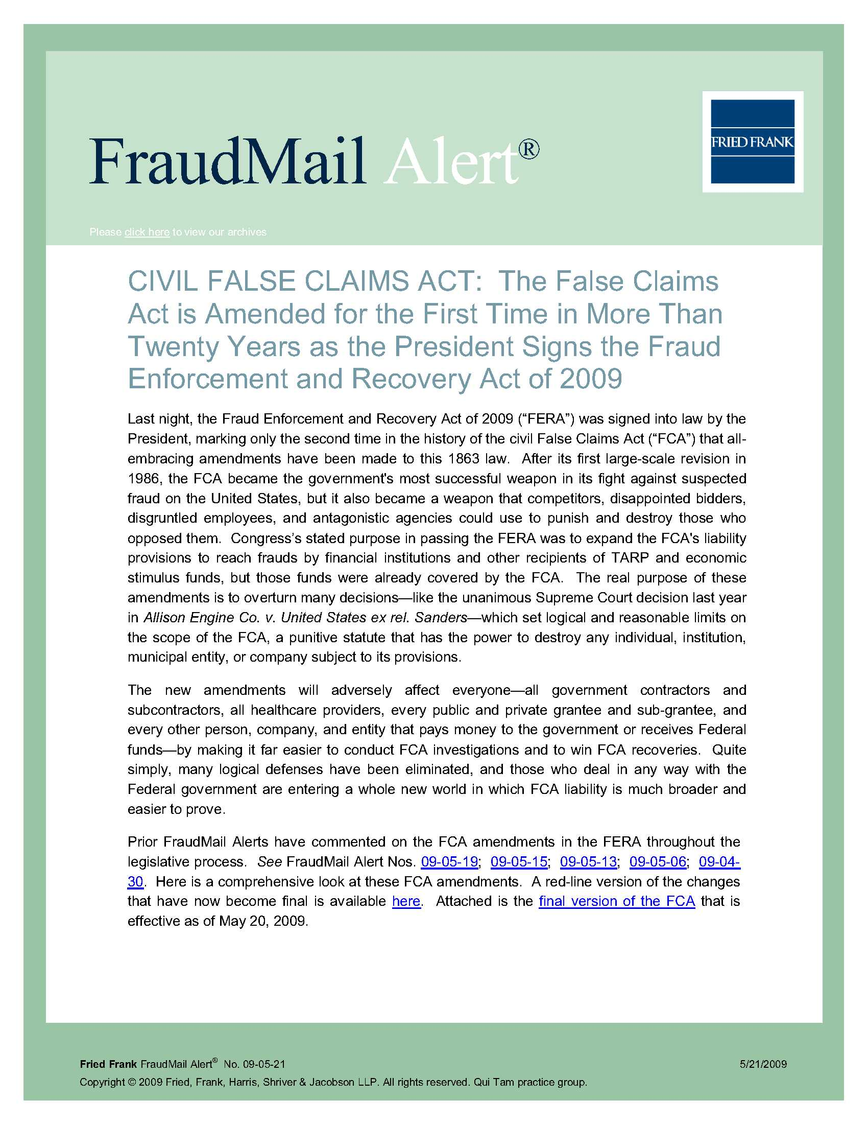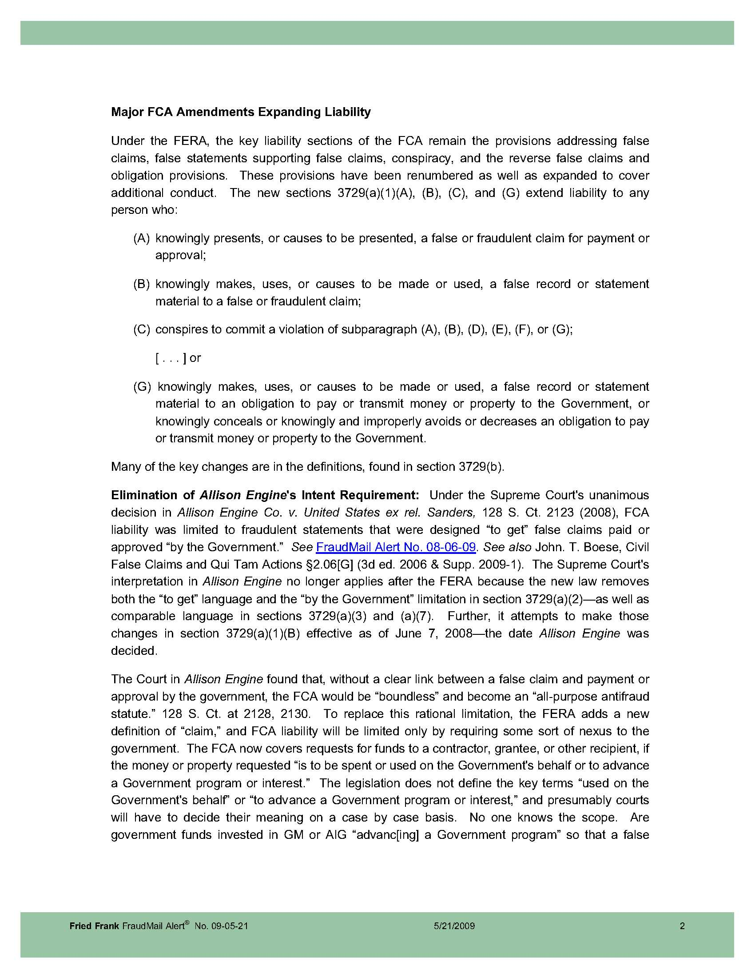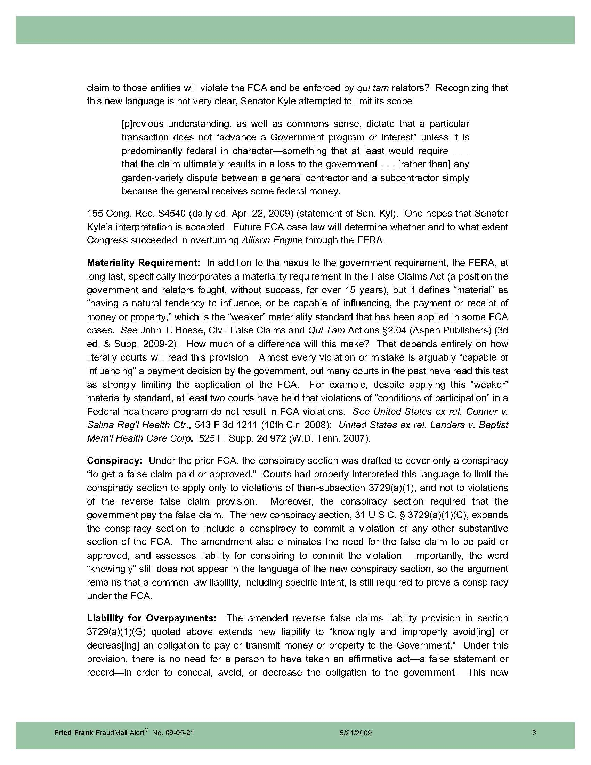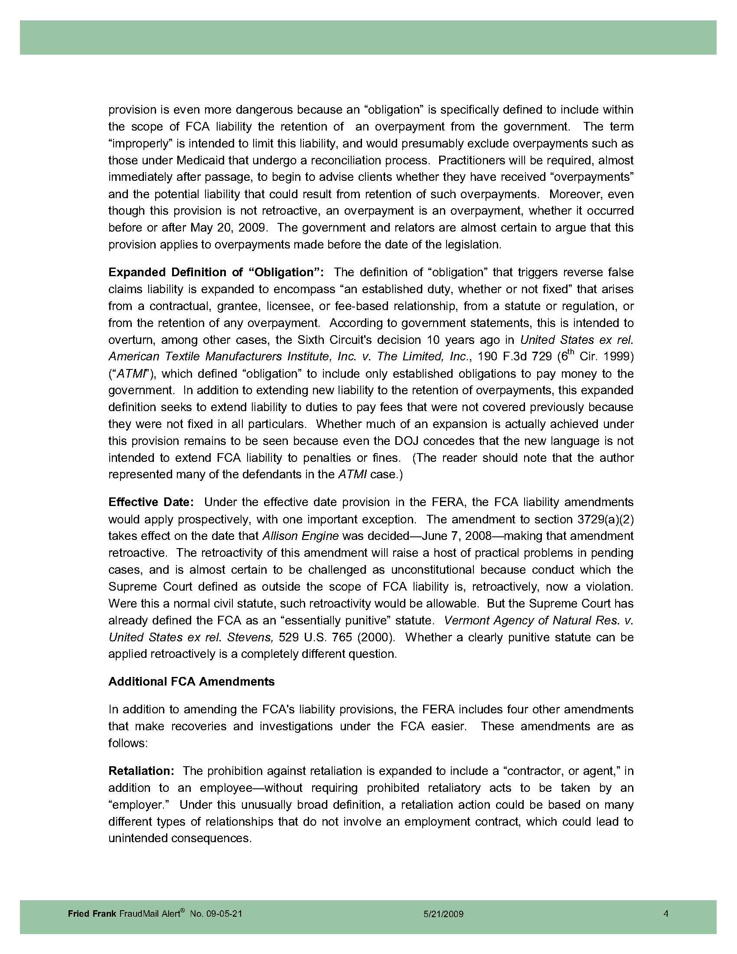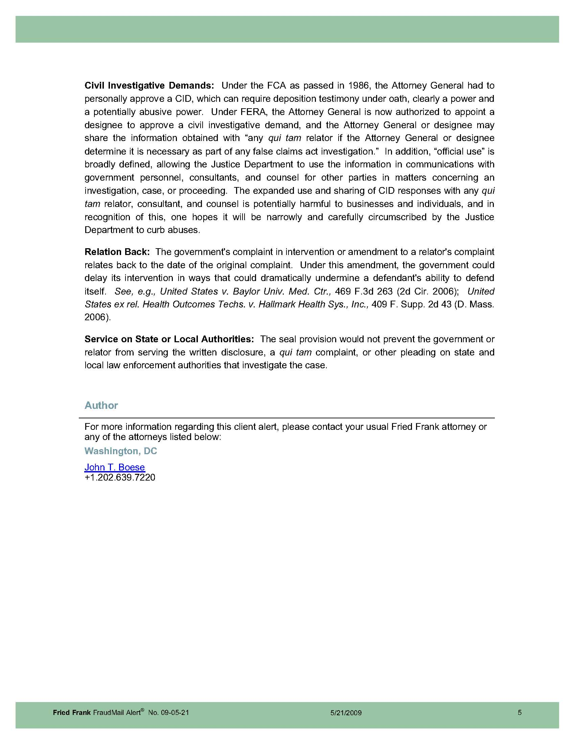
Appendix 3

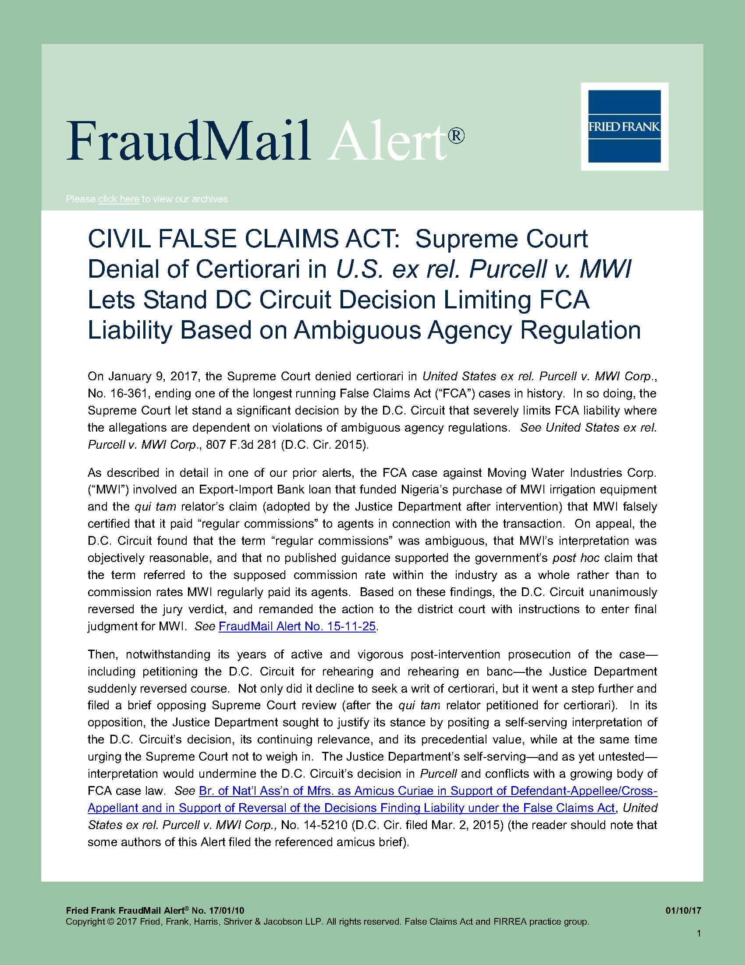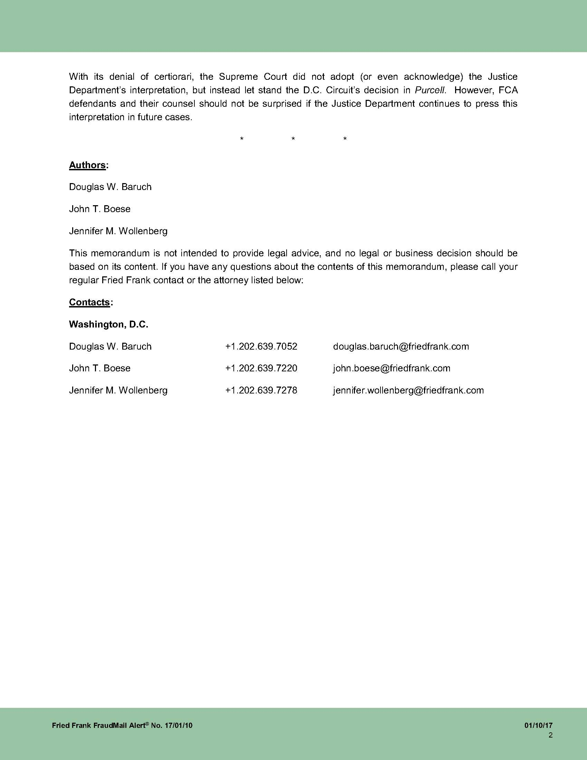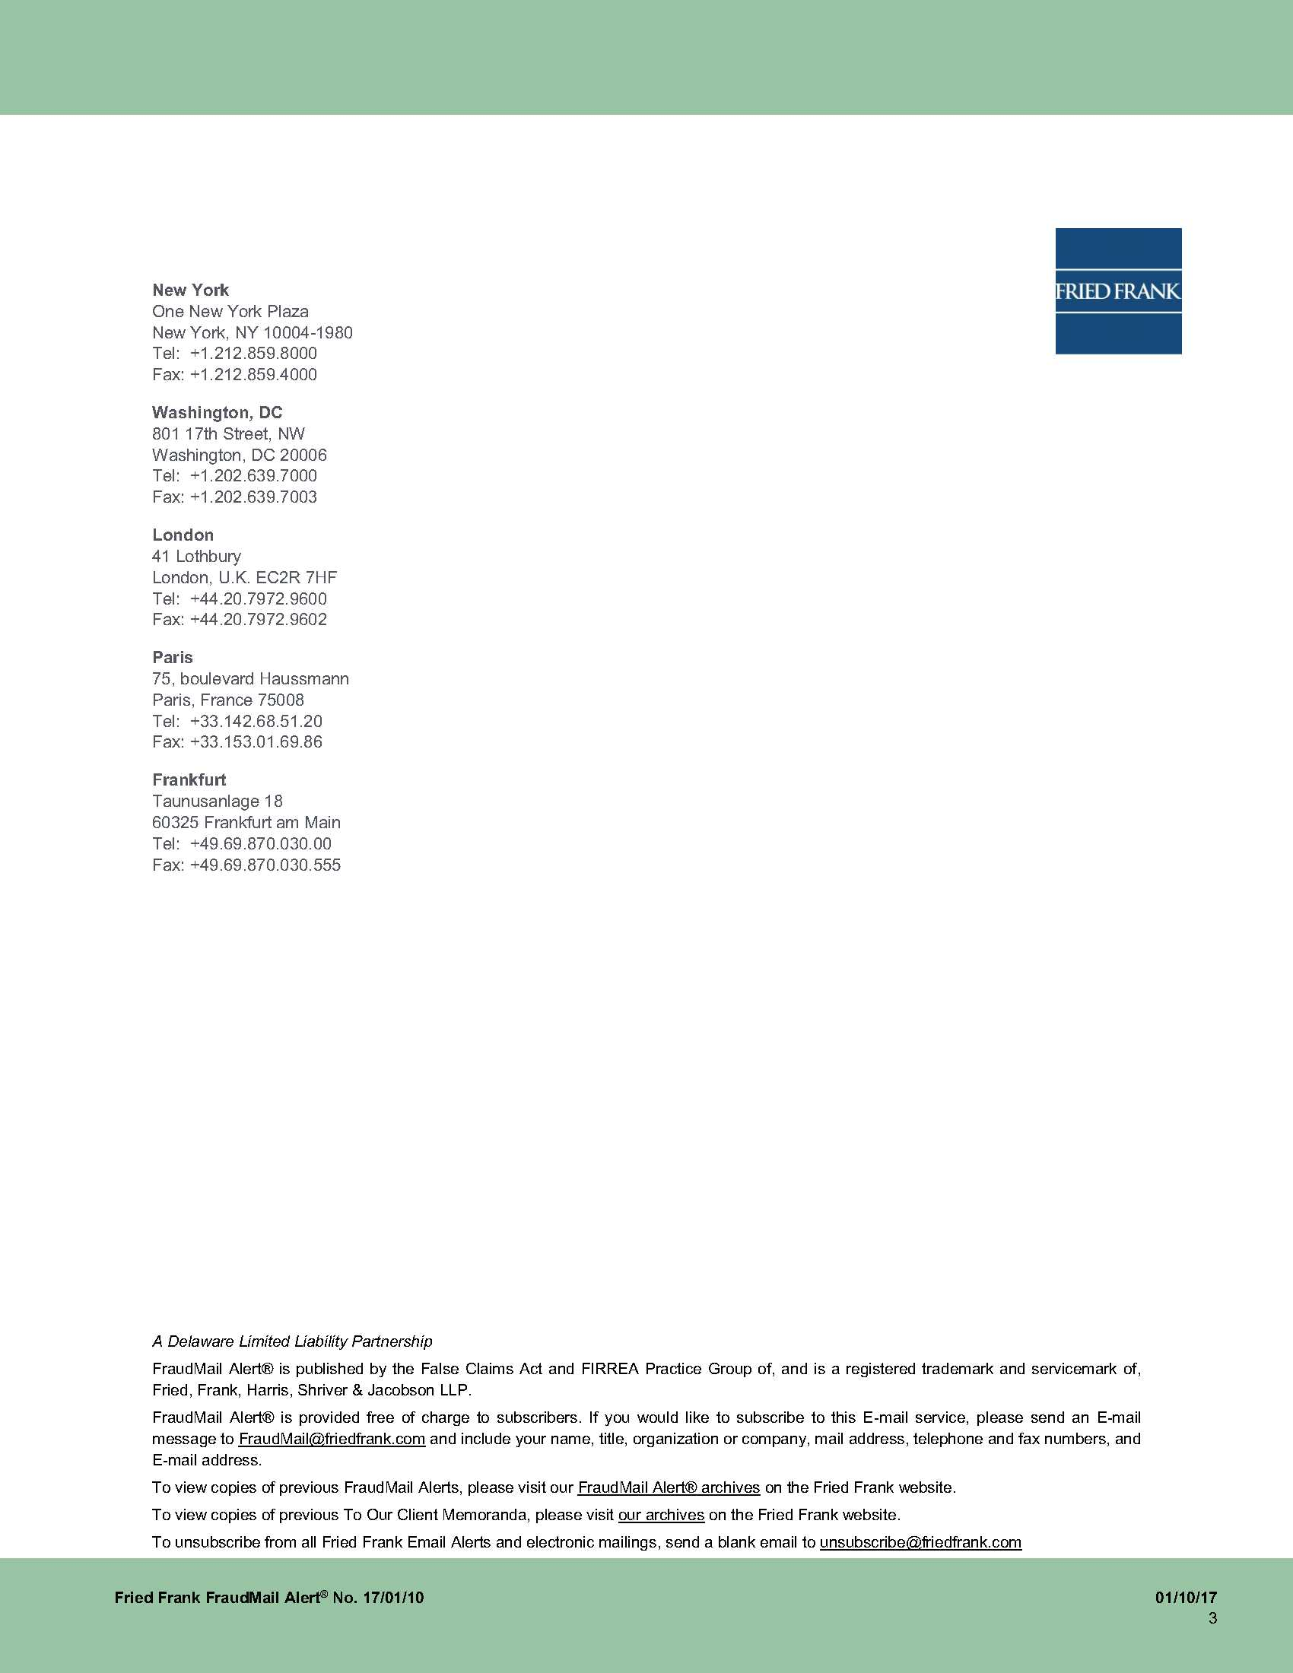

Appendix 4

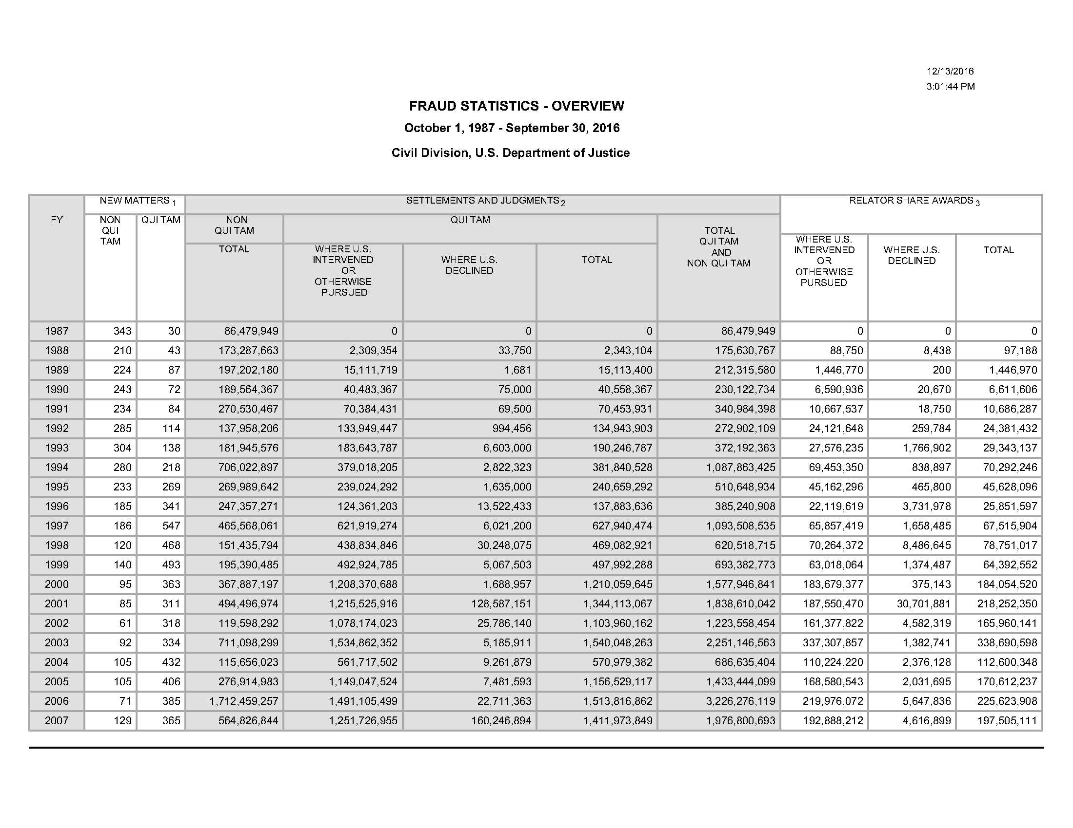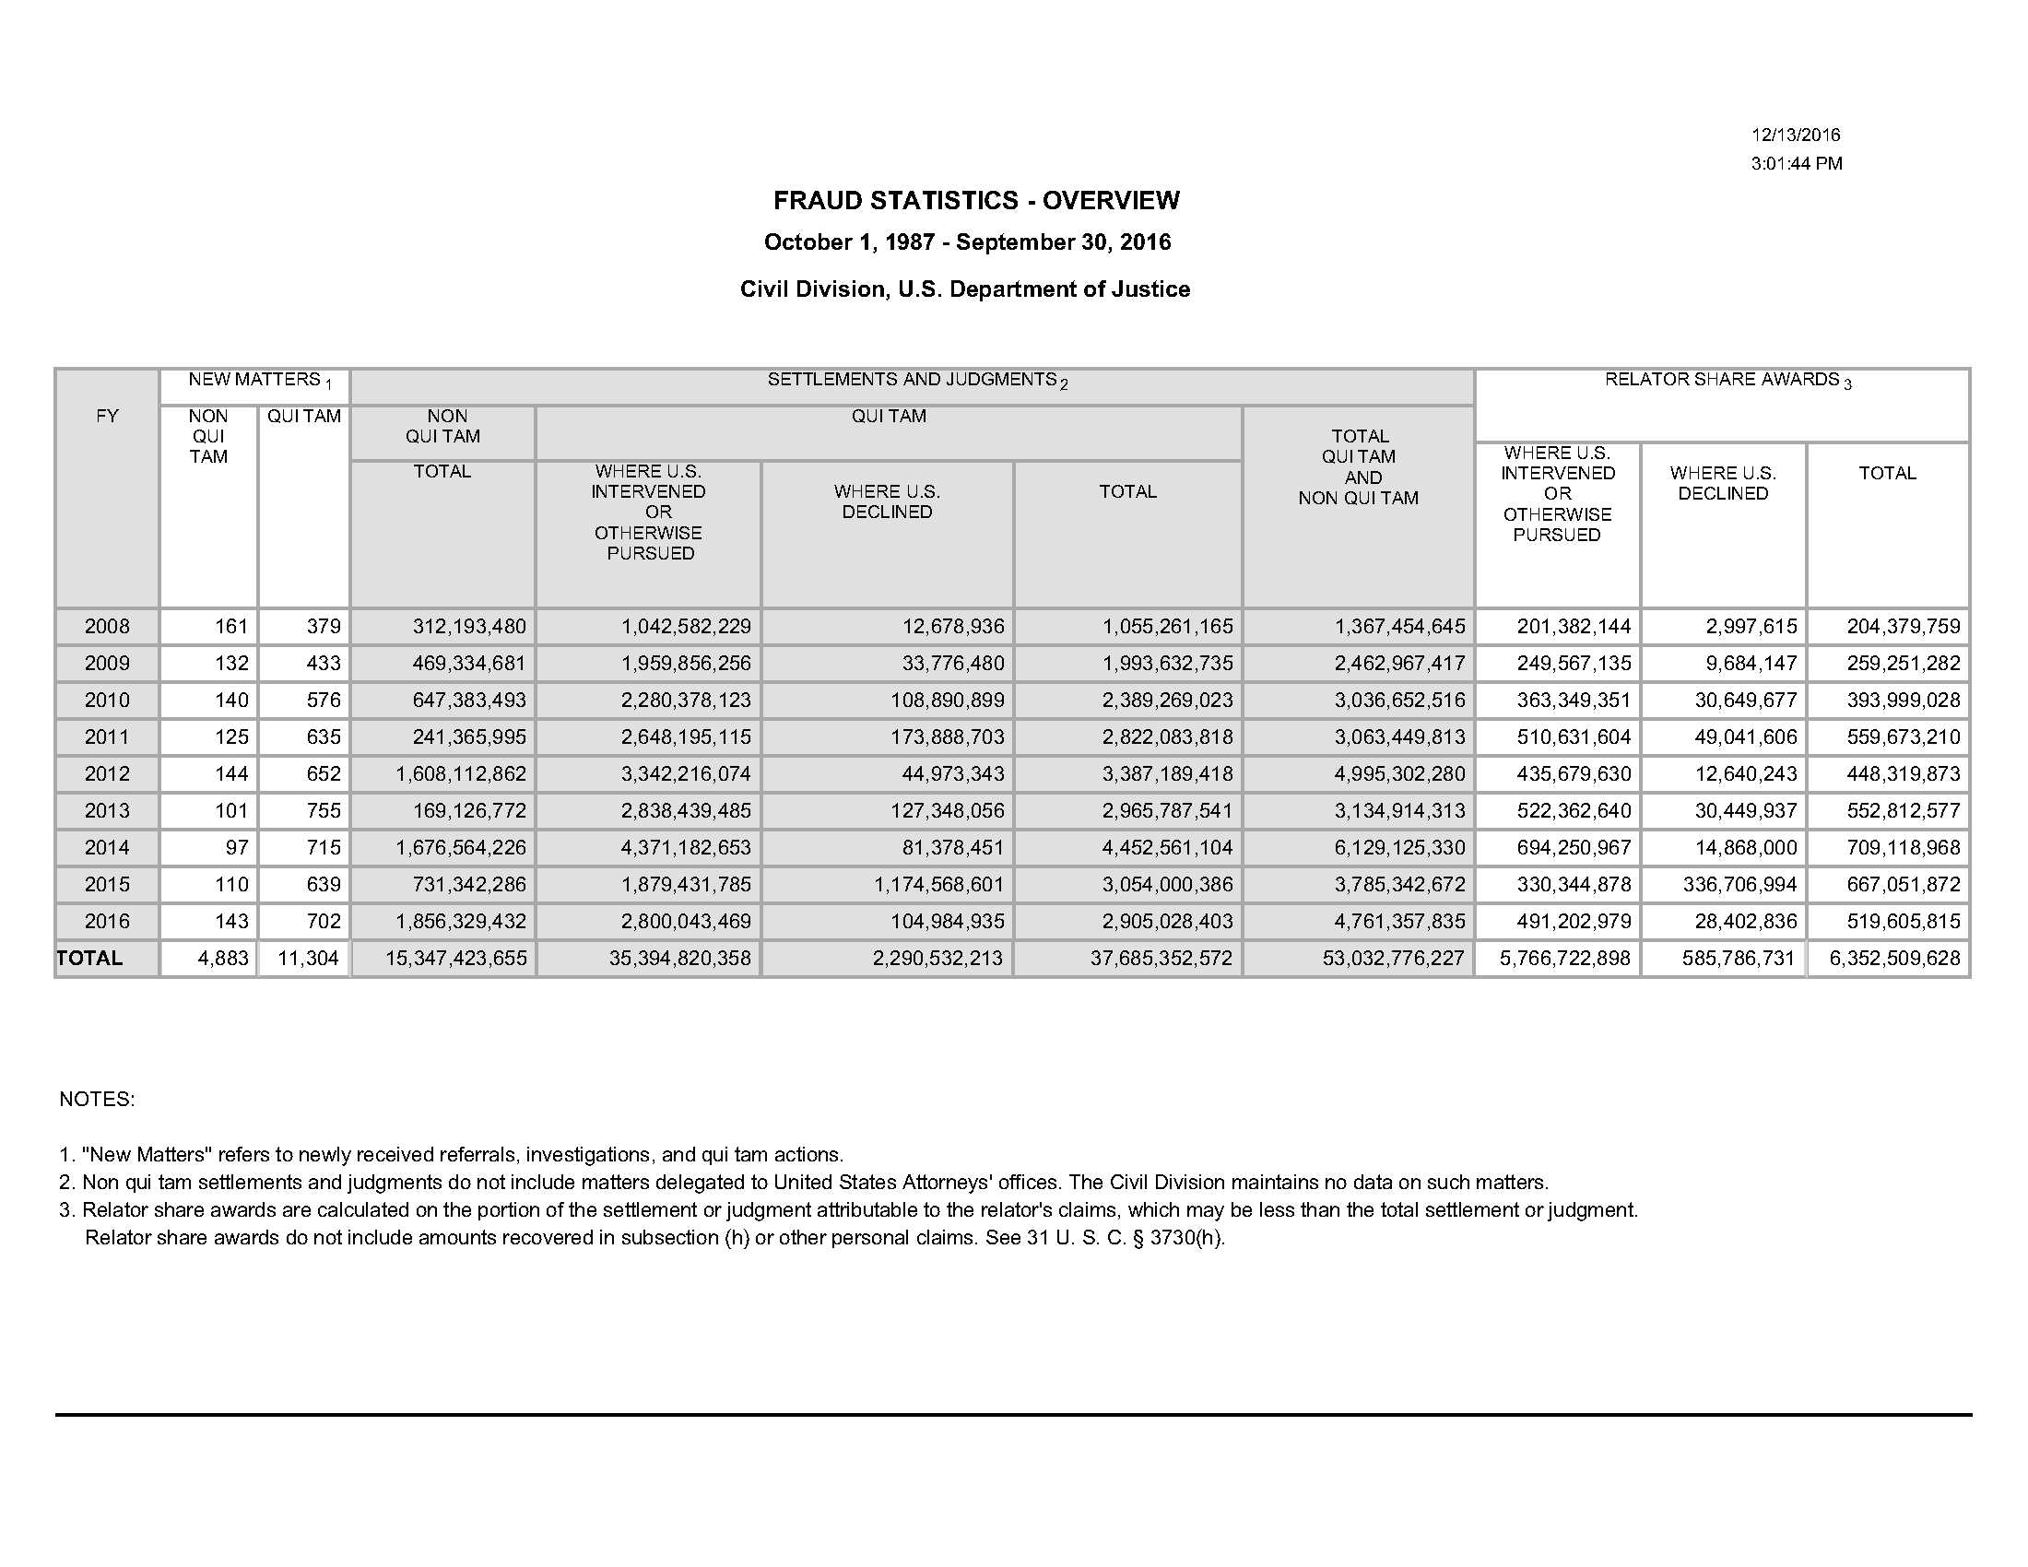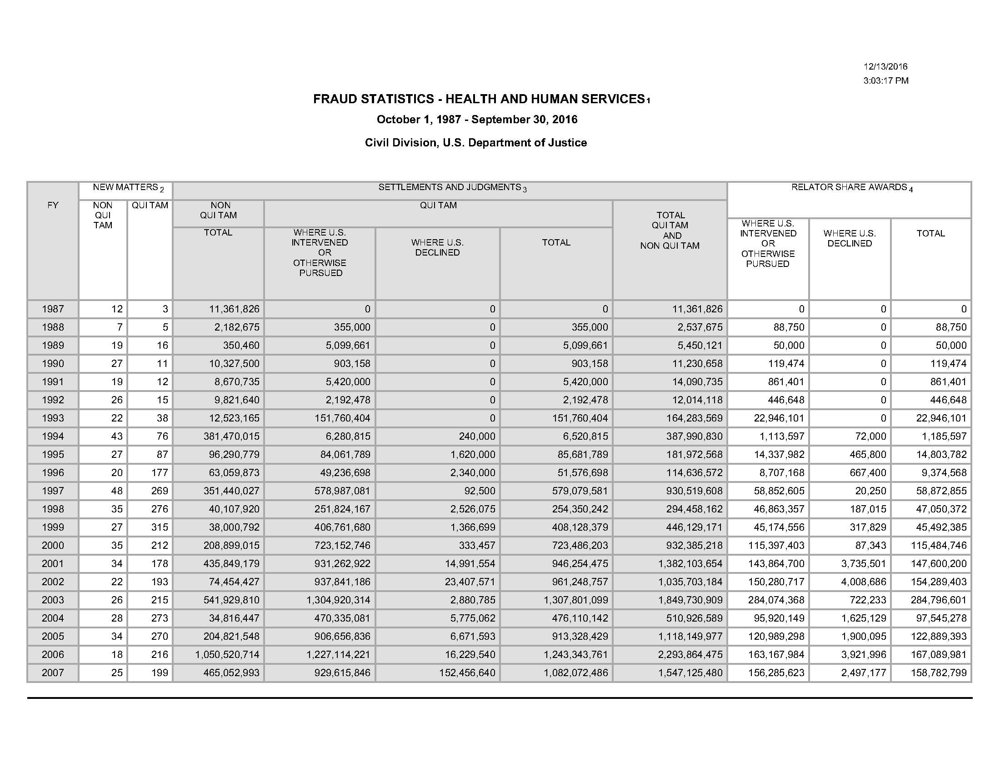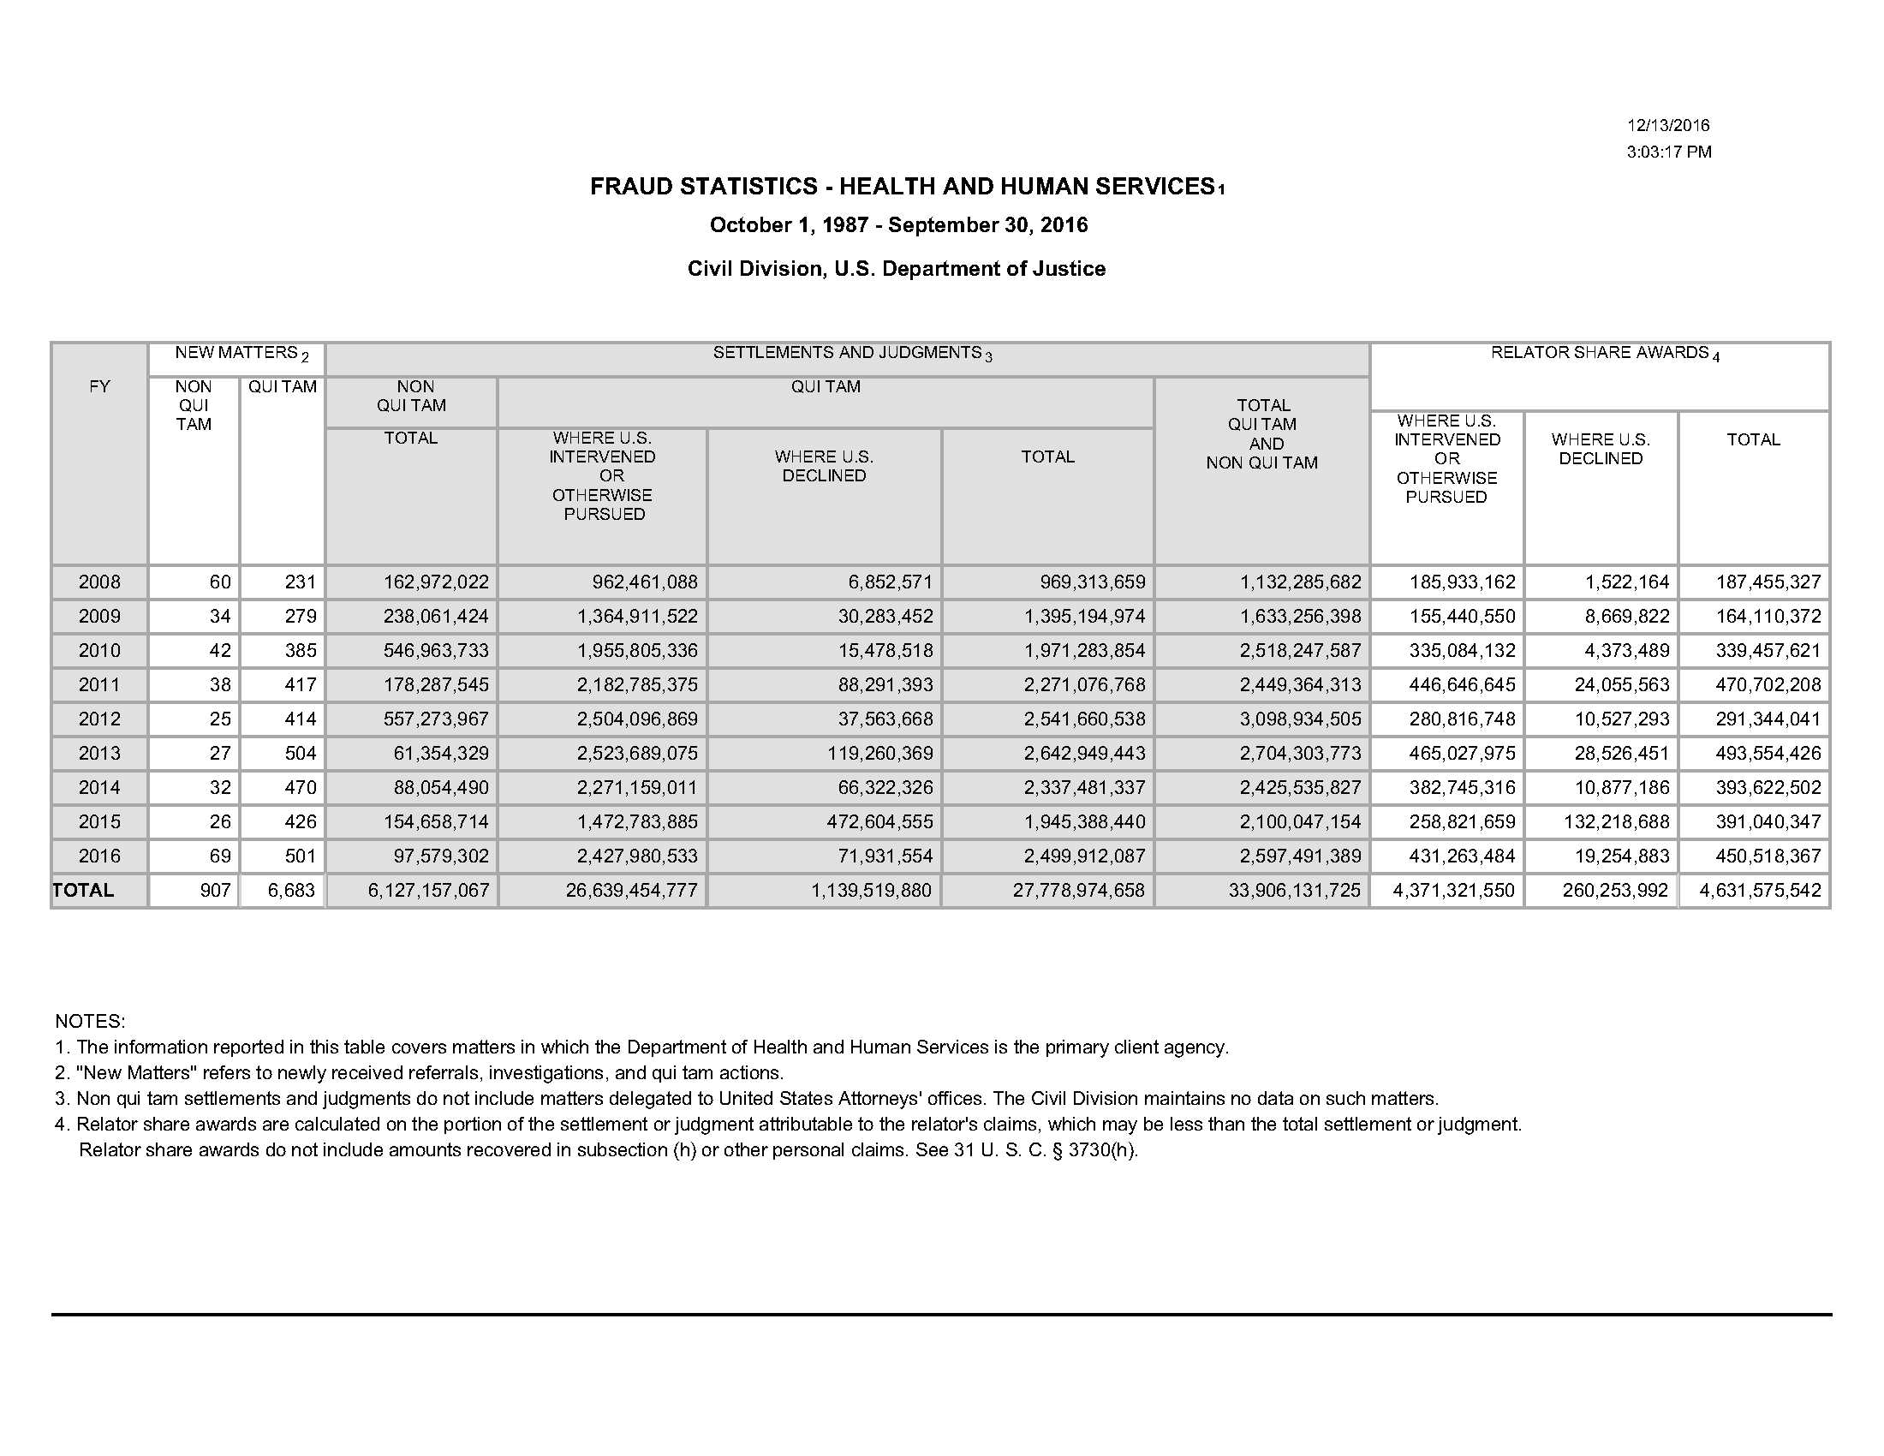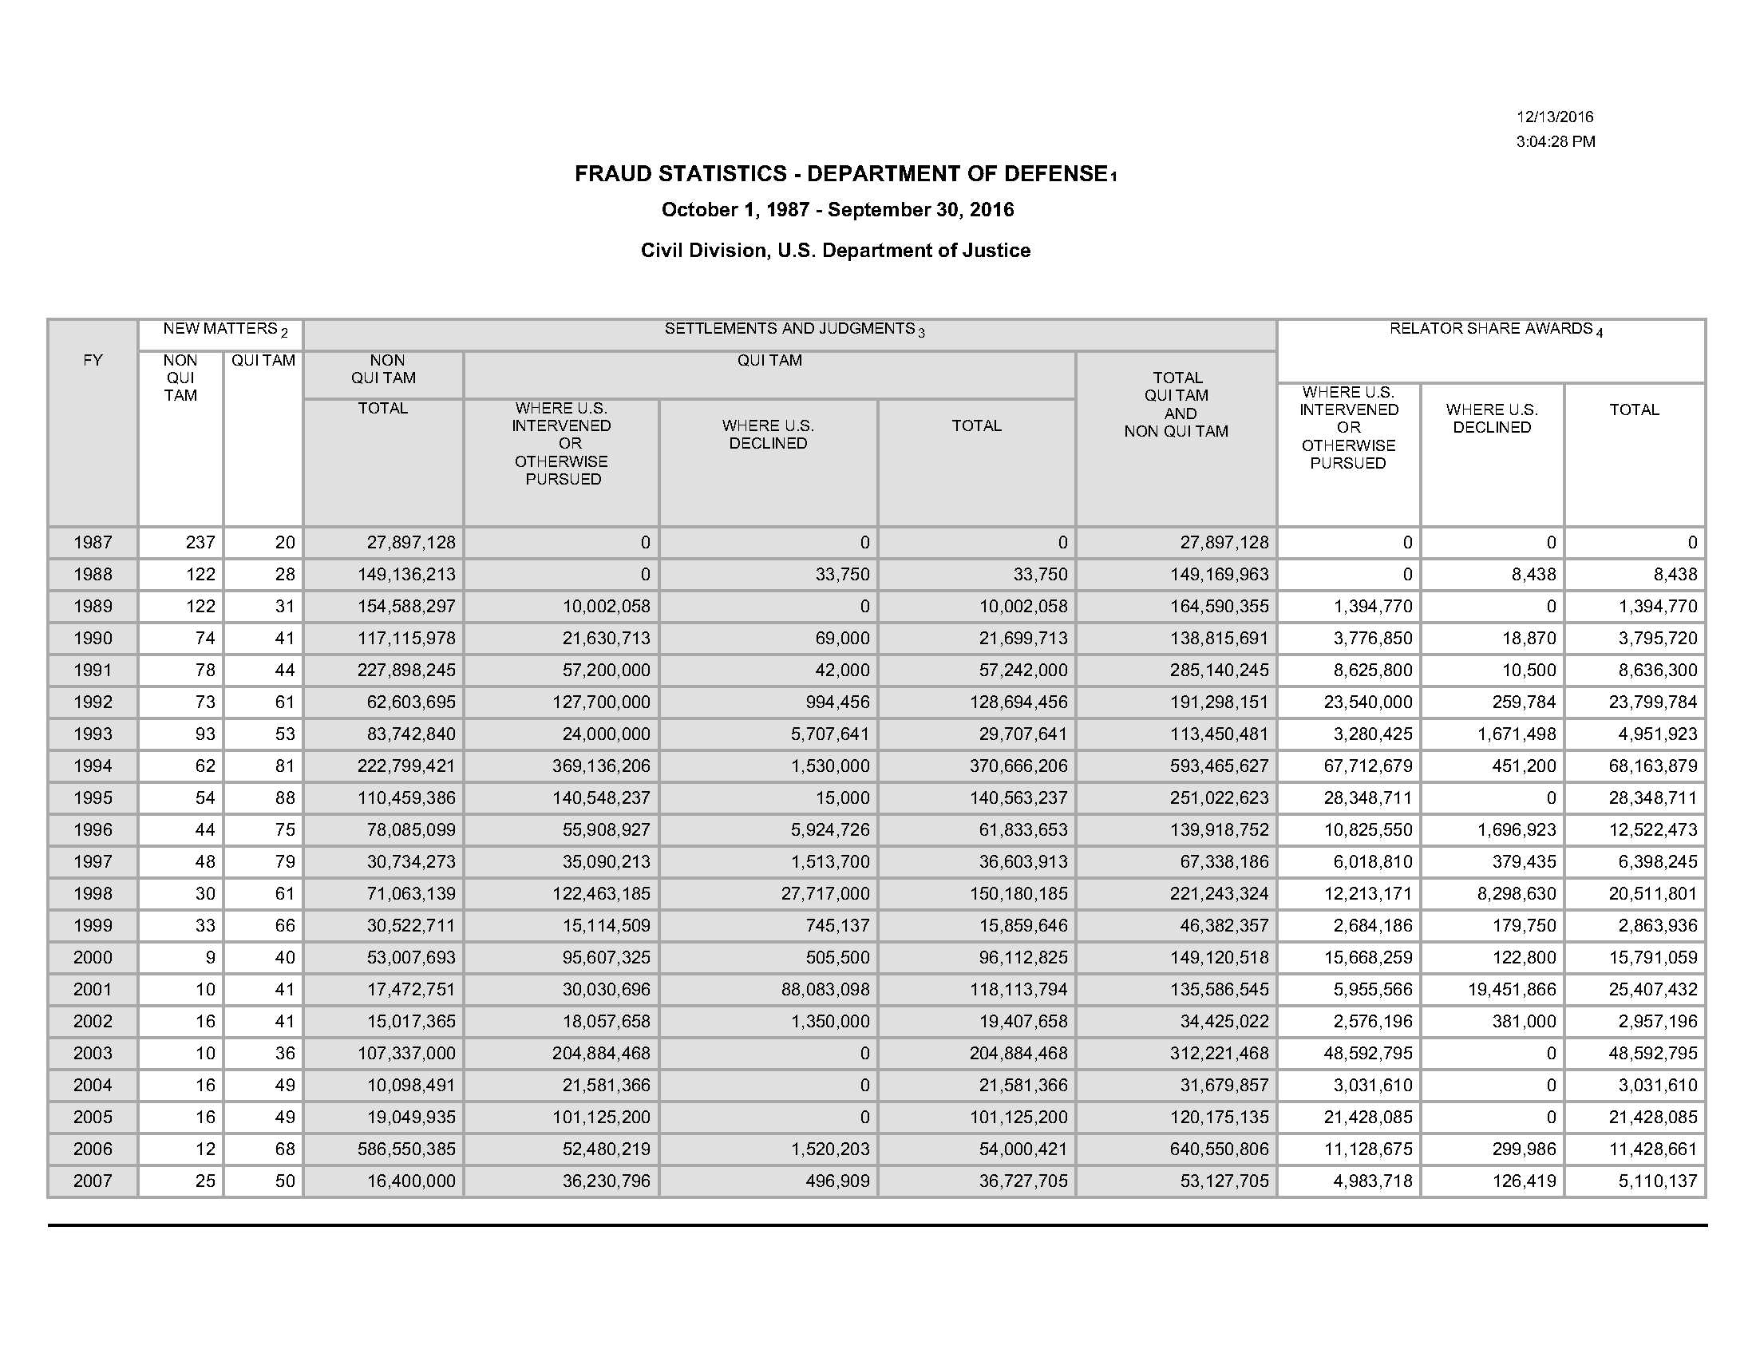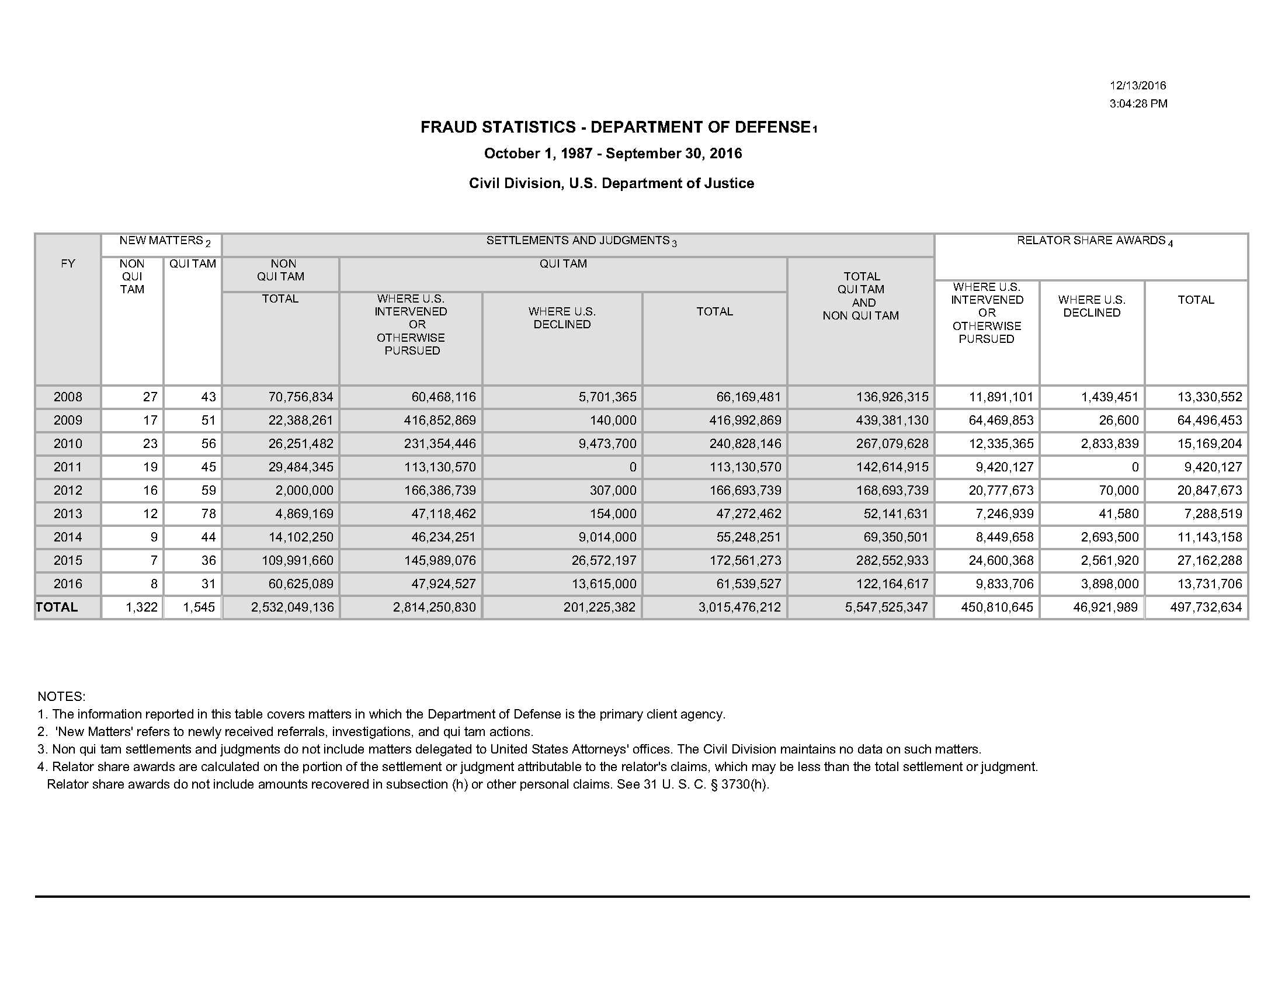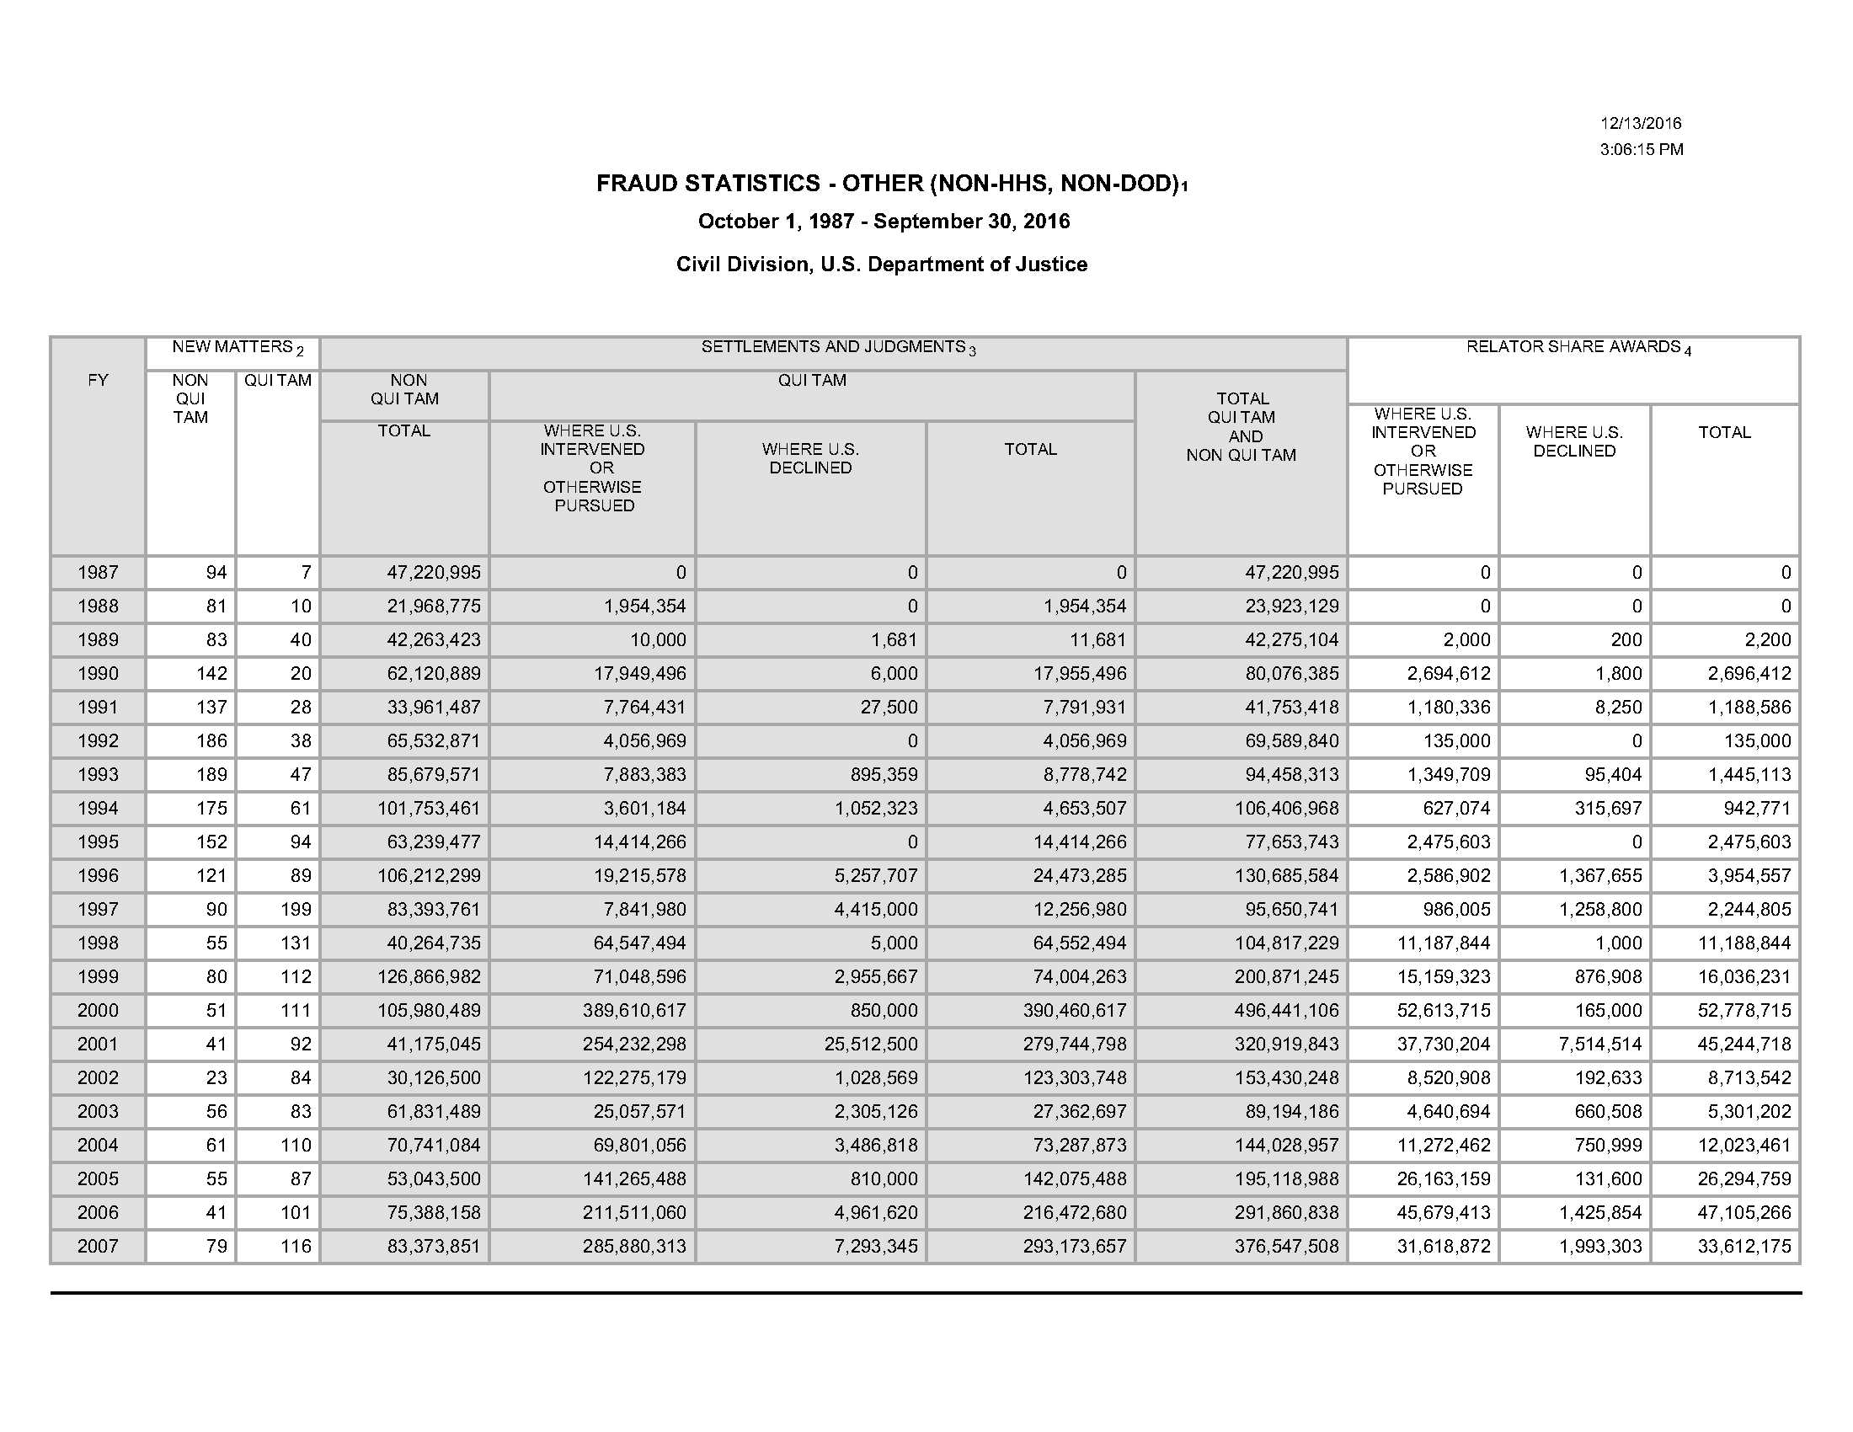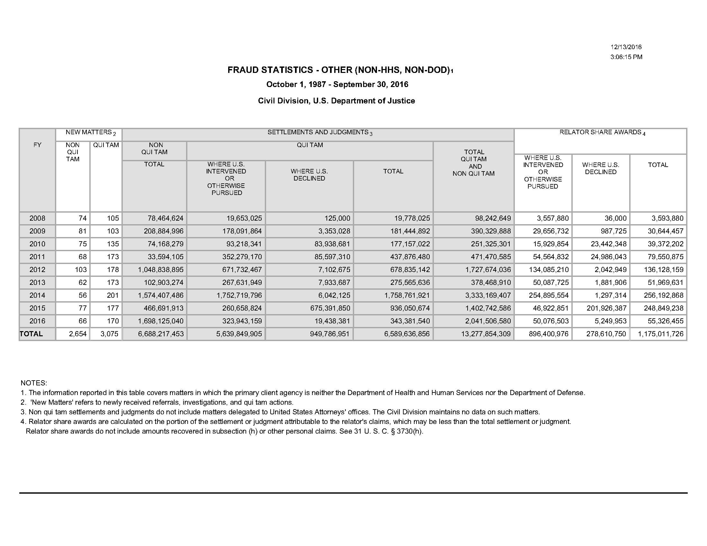

See Press Release, Dep’t of Justice, Justice Department Recovers Over $4.7 Billion from False Claims Cases in Fiscal Year 2016 (Dec. 14, 2016) (“DOJ’s 2016 Press Release”). See also DOJ’s 2016 FCA Statistics (attached as Appendix4)
See DOJ’s 2016 Press Release.
See Memorandum from Deputy Att’y Gen. Sally Quillian Yates, Individual Accountability for Corporate Wrongdoing (Sept. 9, 2015) (“Yates Memo”), https://www.justice.gov/dag/file/769036/download; Press Release, Dep’t of Justice, Principal Deputy Assistant Att’y Gen. Benjamin C. Mizer Delivers Remarks at the 16th Pharm Compliance Cong. and Best Practices Forum (Oct. 22, 2015), https://www.justice.gov/opa/speech/principal-deputy-assistant-attorney-general-benjamin-c-mizer-delivers-remarks-16th.
See FERA, Pub. L. No. 111-21 (2009); ACA, Pub. L. No. 111-148, 124 Stat. 119 (2010); Dodd-Frank Act, Pub. L. No. 111-203, §3301, 124 Stat. 1376, 2079 (2010).
Pub. L. No. 109-171, §§ 6031-6033, 120 Stat. 4, 72-74 (2006) (to be codified at 42 U.S.C. §§ 1396a(a), 1396b(i), 1396h(a)).
31 U.S.C. § 3729(e) provides that “This section does not apply to claims, records, or statements made under the Internal Revenue Code of 1954.”
United States ex rel. Lissack v. Sakura Global Capital Mkts., Inc., 377 F.3d 145 (2d Cir. 2004). Congress has enacted a “tax qui tam” statute which provides a bounty to anyone who brings tax underpayments by certain corporations and high-income individuals to the attention of the IRS. See Tax Relief and Health Care Act of 2006, Pub. L. No. 109-432, §406, 120 Stat. 2922, 2958 (Dec. 20, 2006). See also Boese, §1.07[A][1].
See N.Y. State Fin. Law §189.4(a). See also FraudMail Alert No. 10-08-26, New York State FCA: New York’s False Claims Act Now Equals or Exceeds Federal Fraud Law―False State Tax Returns Are Now Privately Enforceable under State FCA, http://friedlive.icvmgroup.net/siteFiles/Publications/Fried%20Frank%20FraudMail%20Alert.pdf.
31 U.S.C. § 3731(c).
For a review of the limited case law arising under subsections (a)(4), (a)(5), and (a)(6), see Boese, §§ 2.01[G] - [J].
553 U.S. 662 (2008).
Compare Hopper v. Solvay Pharmaceuticals, Inc., 588 F.3d 1318, 1327 (11th Cir. 2009) (defining “claim” as a demand for payment as under Section 3729(b)(2)(A) and finding that no such claims were pending as of June 7, 2008), and Allison Engine Co. v. United States ex rel. Sanders, No. 1:95CV970, 2009 WL 3626773 (S.D. Ohio Oct. 27, 2009) (defining “claim” as a demand for payment, and finding that applying the amendment retroactively would violate the Ex Post Facto Clause), and United States v. Science Applications Int’l Corp., No. 04-1543, 2009 WL 2929250 (D.D.C. Sept., 14, 2009), with United States ex rel. Kirk v. Schindler Elevator Corp., 601 F.3d 94 (2d Cir. 2010) (applying amendment retroactively because relator’s claim was pending as of June 7, 2008), and United States ex rel. Steury v. Cardinal Health, Inc., 625 F.3d 262 (5th Cir. 2010) (same). See also New York v. Sprint Nextel Corp., No. 103917/2011 (N.Y. Sup. Ct. July 1, 2013) (slip op.) (ruling that the New York FCA’s tax liability amendment was not sufficiently punitive in nature or effect to preclude its retroactive application under the Ex Post Facto Clause); United States ex rel. Romano v. New York-Presbyterian Hosp., No. 00 Civ. 8792(LLS), 2008 WL 612691 (S.D.N.Y. Mar. 5, 2008) (ruling that the relator could not add state FCA claims to federal claims that were based on Medicaid claims submitted more than six years prior to the New York FCA’s effective date).
See Appendix 2 at 5 (discussing CID amendment).
See Order No. 3134-2010 (Jan. 15, 2010).
See Dep’t of Justice, Directive No. 1-10, Redelegation of Authority of Assistant Attorney General, Civil Division, to Branch Directors, Heads of Offices and United States Attorneys in Civil Division Cases (Mar. 8, 2010) (to be codified at 28 C.F.R. Part 0).
In fiscal year 2011, DOJ authorized the issuance of 888 CIDs—more than ten times the number issued during the two years before re-delegation combined. See Press Release, Dep’t. of Justice, Acting Assistant Attorney General Stuart F. Delery Speaks at the American Bar Association’s Ninth National Institute on the Civil False Claims Act and Qui Tam Enforcement (June 7, 2012), http://www.justice.gov/iso/opa/civil/speeches/2012/civ-speech-1206071.html.
See Appendix 2 at 5 (discussing relation-back amendment).
See id. at 4 (explaining FERA’s retaliation amendments).
136 S. Ct. 1986 (2016).
No. 15-513, 2016 WL 7078622 (U.S. Dec. 6, 2016).
United States ex rel. Donegan v. Anesthesia Assocs. of Kan. City, PC, 833 F.3d 874 (8th Cir. 2016). See United States ex rel. Purcell v. MWI Corp., 807 F.3d 281 (D.C.Cir. 2015) (reaffirming that there can be no FCA liability where the law or regulation is ambiguous, the defendant’s interpretation of the language is reasonable, and the agency issued no formal guidance indicating the defendant’s interpretation was wrong).
553 U.S. 662 (2008).
553 U.S. at 669, 672.
707 F.3d 451, 456 (4th Cir. 2013) (internal citations omitted)).
565 F.3d 180 (5th Cir. 2009).
579 F.3d 13 (1st Cir. 2009). It should be noted that the scope of the claims in Duxbury were strictly limited when the First Circuit affirmed the district court’s order limiting discovery to the claims that survived dismissal and precluding the relator from discovery on “nationwide” fraud that was outside the time frame and geographic location of the original relator’s employment. See United States ex rel. Duxbury v. Ortho Biotech Prods., LP, 719 F.3d 31 (1st Cir. 2013).
See, e.g., United States ex rel. Karvelas v. Melrose-Wakefield Hosp., 360 F. 3d 220, 226 (1st Cir. ), cert. denied, 125 S. Ct. 59 (2004); United States ex rel. Clausen v. Lab. Corp. of Am. 290 F.3d 1301, 1313, 1316-17 (11th Cir. 2002); United States v. Rogan, No. 02-C-3310, 2002 WL 31433390, at *3 (N.D. Ill. 2002).
See, e.g., United States ex rel. Cafasso v. General Dynamics C4 Sys., 637 F.3d 1047, 1057 (9th Cir. 2011); United States ex rel. Lacy v. New Horizons, Inc., 348 F. App’x 421 (10th Cir. 2009); Corsello v. Lincare, Inc. 428 F.3d 1008, 1014 (5th Cir. 2005).
707 F.3d 451, 456 (4th Cir. 2013).
See, e.g., United States ex rel. Duxbury v. Ortho Biotech Prods., L.P., 579 F.3d 13 (1st Cir. 2009); United States ex rel. Foglia v. Renal Ventures Management, LLC, 754 F.3d 153 (3d Cir. 2014); United States ex rel. Grubbs v. Kanneganti, 565 F.3d 180 (5th Cir. 2009); United States ex rel. Prather v. Brookdale Senior Living Communities, Inc., 838 F.3d 750 (6th Cir. 2016); United States ex rel. Presser v. Acacia Mental Health Clinic, LLC, 836 F.3d 770 (7th Cir. 2016); United States ex rel. Thayer v. Planned Parenthood, No. 13-1654, 2014 WL 4251603 (8th Cir. Aug. 29, 2014); Ebeid v. Lungwitz, 616 F.3d 993 (9th Cir. 2010); United States ex rel. Mastej v. Health Mgmt. Assocs., Inc., 591 F. App’x 693, 708 (11th Cir. 2014).
See, e.g., United States ex rel. Nathan v. Takeda Pharms. N. Am., Inc., 707 F.3d 451 (4th Cir. 2013), cert. denied, 81 U.S.L.W. 3650 (U.S. Mar. 31, 2014) (No. 12-1349); United States ex rel. SNAPP, Inc. v. Ford Motor Co., 618 F.3d 505 (6th Cir. 2010). See also United States ex rel. Siegel v. Roche Diagnostics Corp., 988 F. Supp. 2d 341 (E.D.N.Y. 2013) (applying a heightened standard that requires an actual false claims to be pled).
See, e.g., United States ex rel. Grenadyor v. Ukranian Village Pharmacy, Inc., 772 F.3d 1102 (7th Cir. 2014); United States ex rel. Dunn v. North Mem’l Health Care, 739 F.3d 417 (8th Cir. 2014); United States ex rel. Ge v. Takeda Pharm. Co., 737 F.3d 116 (1st Cir. 2013); United States ex rel. Nunnally v. W. Calcasieu Cameron Hosp., 519 F. App’x 890, 892-95 (5th Cir. 2013) (unpublished decision).
See, e.g., United States ex rel. Lusby v. Rolls-Royce Corp., No. 1:03CV680-SEB-WGH, 2012 WL 4357438 (S.D. Ind. Sept. 24, 2012) (granting summary judgment to defendant because relator had no proof that Rolls–Royce made a false claim for payment to the government); United States ex rel. Duxbury v. Ortho Biotech Prods., LP, 719 F.3d 31 (1st Cir. 2013) (“Duxbury II”) (granting summary judgment to defendant).
See United States v. Diogo, 320 F.2d 898 (2d Cir. 1963); United States v. Lange, 528 F.2d 1280 (5th Cir. 1976).
See, e.g., United States ex rel. Hill v. University of Medicine & Dentistry of N.J., No. 10-4364, 2011 WL 5008427 (3d Cir. Oct. 20 2011) (finding that scientific judgments or conclusions on which reasonable minds may differ cannot be “false”); United States ex rel. Morton v. A Plus Benefits, Inc., No. 04-4148, 139 F. App’x 980 (10th Cir. July 19, 2005) (unpublished decision); United States ex rel. Polukoff v. St. Mark’s Hosp., No. 2:16CV00304-JNP-EJF, 2017 WL 237615 (D. Utah Jan. 19, 2017) (physician’s medically reasonable and necessary representation could not be proven false because it was a medical judgment about which reasonable minds may differ); United States ex rel. Milam v. Regents of the Univ. of California, 912 F. Supp. 868, 886 (D. Md. 1995).
See United States ex rel. Foglia v. Renal Ventures Mgmt., LLC, 754 F.3d 153 (3d Cir. 2014) (finding that relator’s allegation that Renal’s overfill claim misrepresented goods provided and overcharged the government was a “factually false claim”); United States ex rel. Conner v. Salina Reg’l Health Ctr., Inc., 543 F.3d 1211, 1217 (10th Cir. 2008) (distinguishing factually false from legally false claims); United States ex rel. Mikes v. Straus, 274 F.3d 687, 697 (2d Cir. 2001) (same); United States ex rel. Sanchez-Smith v. AHS Tulsa Reg’l Med. Ctr., 754 F. Supp. 2d 1270, 1288 (N.D. Okla. 2010) (finding no evidence that services were so deficient that claims were factually false and rejecting relators’ allegations that “would stretch FCA ‘factual’ falsity liability too far beyond its intended purpose of preventing misrepresentations of fact on claim forms”).
See, e.g., United States ex rel. Bishop v. Wells Fargo & Co., No. 15-2449, 2016 WL 2587426 (2d Cir. May 5, 2016) (stating that the Mikes express test holding is not limited to the healthcare industry, and concluding that some of the same concerns raised in the Medicare fraud context in Mikes are also relevant to the banking industry); United States ex rel. Mikes v. Straus, 274 F.3d 687, 697 (2d Cir. 2001) ("a claim under the Act is legally false only where a party certifies compliance with a statute or regulation as a condition to governmental payment."); United States ex rel. Siewick v. Jamieson Sci. & Eng'g, Inc., 214 F.3d 1372, 1376 (D.C. Cir. 2000) (relator's implied certification theory was "doomed by the rule, adopted by all courts of appeals to have addressed the matter, that a false certification of compliance with a statute or regulation cannot serve as the basis for a qui tam action under the FCA unless payment is conditioned on that certification.”); United States ex rel. Lamers v. City of Green Bay, 168 F.3d 1013, 1019 (7th Cir. 1999).
136 S. Ct. 1989 (2016).
See, e.g., Augustine, supra note 19; Shaw v. AAA Eng'g & Drafting, Inc., 213 F.3d 519 (10th Cir. 2000) (affirming the imposition of liability for allegedly false implied certifications of contractual compliance). See also United States ex rel. Hutcheson v. Blackstone Med., Inc., 647 F.3d 377 (1st Cir. 2011) (rejecting the argument that, in the absence of an express legal representation or factual misstatement, a claim can only be false or fraudulent if it fails to comply with a precondition of payment expressly stated in a statute or regulation, finding that the non-defendant hospital’s claims to Medicare could be rendered false by alleged underlying kickback violations of other defendants, and ruling that the alleged kickbacks violated preconditions to Medicare’s payment in the physicians’ and hospital’s provider agreements and in the hospital’s cost reports).
See,e.g., United States ex rel. Rostholder v. Omnicare, Inc., 745 F.3d 694 (4th Cir.), cert. denied, 135 S. Ct. 85 (2014) (holding that claims for drugs re-packaged in violation of FDA processing regulations were not “false”); United States ex rel. Steury v. Cardinal Health, Inc., 625 F.3d 262 (5th Cir. 2010) (ruling that an “underlying claim for payment is not ‘false’ within the meaning of the FCA if the contractor was not required to certify compliance in order to receive payment”); United States ex rel. Hobbs v. MedQuest Assocs., Inc., 711 F.3d 707 (6th Cir. 2013 (holding that “approved physician” and updating enrollment information requirements were not conditions of Medicare payment); United States ex rel. Hill v. City of Chicago, 772 F.3d 455 (7th Cir. 2014) (affirming dismissal of relator’s false certification allegation that program as implemented differed from the City’s grant application for lack of falsity); United States ex rel. Ketroser v. Mayo Found., 729 F.3d 825 (8th Cir. 2013) (“[t]he absence of a clear requirement that a written report must underlie or support each claim for surgical pathology services means that Relators pleaded a claim of regulatory noncompliance, not a plausible claim that Mayo submitted false or fraudulent claims for Medicare payment.”). See also FraudMail Alert No. 10-11-03, Fifth Circuit Holds “Prerequisite to Payment” is a Fundamental Requirement in Establishing “Falsity” in a False Certification Case (Nov. 3, 2010), http://www.friedfrank.com/siteFiles%2FPublications%2FFried%20Frank%20FraudMail%20Alert%20No.%2010-11-03.pdf.; FraudMail Alert No. 11-08-31, Sixth Circuit Joins Second and Fifth Circuits in Holding That FCA Claims Based on Implied False Certifications Must Allege and Prove That the Alleged Violation Was a Prerequisite to Payment (Aug. 31, 2011), http://www.friedfrank.com/siteFiles%2FPublications%2FFried%20Frank%20FraudMail%20Alert%C2%AE%20No.%2011-08-31.pdf.
625 F.3d 262 (5th Cir. 2010).
625 F.3d at 269.
655 F.3d 461 (6th Cir. 2011).
No. 15-2449, 2016 WL 2587426 (2d Cir. May 5, 2016).
Id. at *10, (quoting Mikes v. Straus, 274 F.3d 687, 699 (2d Cir. 2001)).
274 F.3d at 700.
2016 WL 2587426, at *12.
136 S. Ct. 1989 (2016).
Id. at 2003 (quoting Allison Engine).
See 31 U.S.C. § 3729(b)(4).
543 F.3d 1211 (10th Cir. 2008).
525 F. Supp. 2d 972 (W.D. Tenn. 2007). The reader should note that the author was one of the attorneys representing the defendants in this case.
Escobar, 136 S.Ct. 1989, 1995, 1999.
See, e.g., Blackstone, 647 F.3d 377 (1st Cir. 2011) (noting that “[o]nly persons who knowingly submit or cause the submission of a false or fraudulent claim can be held liable for violating the FCA,” that “[t] he term ‘causes’ is hardly boundless,” and that “it has been richly developed as a constraint in various areas of the law”); United States ex rel. Southland Mgmt. Corp., 326 F.3d 669 (5th Cir. 2003) (en banc); United States ex rel. Tessitore v. Infomedics, Inc., 847 F. Supp. 2d 256 (D. Mass. 2012) (rejecting relator’s theory—that drug manufacturer’s failure to report adverse events kept FDA from requiring warnings sooner, causing more prescriptions for Paxil to be written by physicians and more claims for reimbursement to the government—as an unsupported hypothetical that called for inferences that went against the evidence); Massachusetts v. Shering-Plough Corp., No. 03-11865-PBS, 2011 WL 4436969, at *3 (D. Mass. Sept. 23, 2011) (finding that pharmacists’ claims were factually false, but that defendants had “no role in causing that independent falsehood”).
See, e.g., United States v. Rogan, 517 F.3d 449 (7th Cir. 2008) (applying the "capable of influencing" test of materiality and finding that testimony of a government official showing that it would not have paid was not a required component of materiality).
See John T. Boese, The Past, Present, and Future of “Materiality” Under the False Claims Act, 3 St. Louis U.J. of Health L. & Pol’y 291 (2010).
Escobar, 136 S. Ct. 1989, 2001.
Id. at 2000.
Id. at 2003.
Id. at 2002, 2003.
Id. at 2003.
Id. at 1996.
Id. at 2004 n.6.
840 F.3d 445 (7th Cir. 2016).
Id. Cf. Rose v. Stephens Inst., No. 09-cv-5966-PJH, 2016 WL 6393513 (N.D. Cal. Oct. 28, 2016) (certifying for interlocutory appeal whether Escobar created a two-part mandatory threshold test that applies to every implied false certification claim).
Escobar II, No. 14-1423, 2016 WL 6872650 (1st Cir. Nov. 22, 2016).
D’Agostino, No. 16-1126, 2016 WL 7422943 (1st Cir. Dec. 23, 2016).
See, e.g., United States ex rel. Kelly v. Serco, Inc., No. 14-56769, 2017 WL 117154 (9th Cir. Jan. 12, 2017) (finding cost formatting standard minor and ancillary to contract’s purpose under Escobar); Carlson v. DynCorp Int’l LLC, No. 14-1281, 2016 WL 4434415 (4th Cir. Aug. 22, 2016) (finding alleged violations of accounting regulations or best practices insufficient under Escobar standard).
No. Civ. A. 96-11651PBS, 2003 WL 22048255, at *4 (D. Mass. Aug. 22, 2003). See also United States ex rel. Freedman v. Suarez-Hoyos, MD, No. 8:04CV933-T-24 EAJ, 2012 WL 4344199 (M.D. Fla. Sept. 21, 2012) (citing Parke-Davis and ruling that liability could attach to a kickback arrangement that was a substantial factor in causing presentment of a false claim); United States ex rel. Carpenter v. Abbott Labs., Inc., 723 F. Supp. 2d 395 (D. Mass. 2010) (finding allegations that defendant’s literature compared its drug favorably with other drugs approved for off-label outpatient use and failed to reflect unfavorable information about the drug were sufficient to pass the “substantial factor” test for causation of claims to Medicare for off-label use); United States ex rel. DeCesare v. Americare In Home Nursing, No. 1:05CV696, 2010 WL 5313315, at *13 (E.D. Va. Dec. 16, 2010) (finding that it was a “necessary, foreseeable, and obvious consequence of VNSN's referrals that Medicare and Medicaid claims would be filed,” and therefore that the complaint alleged that VNSN caused false claims to be submitted under the “substantial factor” test); United States ex rel. Strom v. Scios, Inc., 676 F. Supp. 2d 884, 891 (N.D. Cal. 2009) (finding that the causation requirement of Rule 9(b) had been met by the allegation that “Defendants' marketing activities created the market for the outpatient use of [the drug], and . . . encouraged such a use even though they had no credible evidence that [the drug] was effective in that context”).
2003 WL 22048255, at *6.
305 F. Supp. 2d 451 (E.D. Pa. 2004).
553 U.S. 662, 672 (2008).
Id. at 390 (citing Hess, 317 U.S. 537 (1943), and Bornstein, 423 U.S. 303 (1976)).
See United States ex rel. Kester v. Novartis Pharma. Corp., No. 11CV8196(CM), 2014 WL 4230386 (S.D.N.Y. Aug. 7, 2014) (ruling that the government sufficiently pled an AKS violation against Novartis under the express false certification theory without requiring the government to allege that the kickback scheme actually caused the pharmacy’s sale to a particular patient). However, the district court subsequently modified its ruling in Kester based on finding that the AKS could not be a basis for implied false certification liability prior to March 2010 because the AKS did not expressly precondition payment of federal claims prior to that date and Second Circuit precedent in Mikes v. Straus requires an express precondition to payment. Kester, 43 F. Supp. 3d 332 (S.D.N.Y. 2014).
553 U.S. 662, 672 (2008).
See United States v. Krizek, 859 F. Supp. 5 (D.D.C. 1994), aff'd, 111 F.3d 934 (D.C. Cir. 1997).
551 U.S. 47 (2007).
530 F. 3d 980 (D.C. Cir. 2008).
See, e.g., United States ex rel. Donegan v. Anesthesia Assocs. of Kan. City, PC, 833 F.3d 874 (8th Cir. 2016); United States ex rel. Ketroser v. Mayo Found., 729 F.3d 825 (8th Cir. 2013) (“Mayo’s reasonable interpretation of any ambiguity inherent in the regulations belies the scienter necessary to establish a claim of fraud under the FCA”); United States ex rel. Farmer v. City of Houston, 523 F.3d 332 (5th Cir. 2008) (finding that relator could not show that the defendants “knew” of the falsity of the claims because the regulations governing the program were unclear). See also Chapman Law Firm v. United States, No. 09-891C, 2012 WL 256090 (Fed. Cl. Jan. 18, 2012) (applying the doctrine of contra proferentem to the ambiguous contract provision that was drafted by the government, accepting the contractor’s reasonable interpretation, and denying the government’s motion for partial summary judgment on the FCA claim). Cf. United States ex rel. Chilcott v. KBR, Inc., No. 09CV4018, 2013 WL 5781660 (C.D. Ill. Oct. 25, 2013) (finding both interpretations facially reasonable, but drawing from the allegations the “reasonable inference that [Relator’s] interpretation is the correct one” and inferring that “Defendants did not simply choose, in good faith, a reasonable interpretation among equal alternatives”).
807 F.3d 281 (D.C. Cir. 2015). See FraudMail Alert No. 17-01-10, Supreme Court Denial of Certiorari in U.S. ex rel. Purcell v. MWI Lets Stand DC Circuit Decision Limiting FCA Liability Based on Ambiguous Agency Regulation (Jan. 10, 2017) (attached as Appendix 3).
807 F.3d at 287-90.
Id. at 287.
626 F.3d 1257 (D.C. Cir. 2010).
Id. at 1274.
Id. at 1275.
Id. at 1271.
Escobar, 136 S. Ct. 1989, 1996.
190 F.3d 729, 736 (6th Cir. 1999). The reader should note that the author represented the defendants in the ATMI case.
Id. at 742. Other courts reaching similar conclusions include the Eighth Circuit, in United States v. Q International Courier, Inc., 131 F.3d 770 (8th Cir. 1997), the District of Colorado, in United States ex rel. Bahrani v. Conagra, Inc., 338 F. Supp. 2d 1202 (D. Colo. 2004), and the District of Maine, in United States ex rel. S. Prawer & Co. v. Verrill & Dana, 962 F. Supp. 206 (D. Me. 1997). Court decisions that have found an existing “obligation” in cases alleging reverse false claims violations include United States v. Pemco Aeroplex, Inc., 195 F.3d 1234 (11th Cir. 1999) (en banc), United States ex rel. Ervin & Associates v. Hamilton Securities Group, 370 F. Supp. 2d 18 (D.D.C. 2005), and United States v. Raymond & Whitcomb Co., 53 F. Supp. 2d 436 (S.D.N.Y. 1999).
See 155 Cong. Rec. S4539 (daily ed. Apr. 22, 2009) (statement of Sen. Kyl). At one point in the legislative process, there was an intent to overturn the Sixth Circuit’s decision in ATMI, but whether the law as enacted actually did so is questionable because the court found the penalties and duties in ATMI “contingent,” and the definition of “obligation” in Section 3729(b)(3) excludes “contingent” duties.
See, e.g., United States ex rel. Guth v. Roedel Parsons Koch Blache Balhoff & McCollister, No. 15-30043, 2015 WL 5693302 (5th Cir. Sept. 29, 2015) (approving district court’s reasoning in dismissing claim that was predicated on potential or contingent obligation to pay amounts not levied or assessed) (per curiam) (unpublished op.); United States ex rel. Mason v. State Farm Aut. Ins. Co., 398 F. App’x 233, 235 (9th Cir. 2010); United States ex rel. Landis v. Tailwind Sports Corp., No. 1:10-cv-00976 (CRC), 2016 WL 141615 (D.D.C. Jan. 12, 2016); United States ex rel. Branch Consultants, LLC v. Allstate Ins. Co., 668 F. Supp. 2d 780, 811-12 (E.D. La. 2009).
See Simoneaux v. E.I. DuPont DeNemours & Co., No. 12-219-SDD-SCR, 2014 WL 4352185 (M.D. La. Sept. 2, 2014), rev’d, No. 16-30141, 2016 WL 7228813 (5th Cir. Dec. 13, 2016).
No. 16-30141, 2016 WL 7228813 (5th Cir. Dec. 13, 2016).
Id. at *3.
Id. at *6.
839 F.3d 242 (3d. Cir. 2016).
2016 WL 7228813, at *6.
See, e.g., United States ex rel. Ruscher v. Omnicare, Inc., No. 4:08-cv-3396, 2014 WL 43388726 (S.D. Tex. Sept. 5, 2014) (ruling that a fine under a corporate integrity agreement could be an “obligation” under the FCA); Ruscher, 2015 WL 517807 (S.D. Tex. Sept. 3, 2015) (on summary judgment, finding no evidence of a reportable event under Omnicare’s corporate integrity agreement and dismissing reverse false claim); United States ex rel. Boise v. Cephalon, Inc., No. 08-287, 2015 WL 4461793 (E.D. Pa. July 21, 2015) (agreeing with relators that Cephalon’s contractual obligation to pay the government upon breach of its corporate integrity agreement was an “established duty”).
S. Rep. No. 111-10, at 15 (2009).
See ACA, Pub. L. No. 111-148, 124 Stat. 119, § 6402 (2010) (amending 42 U.S.C. §1128J)).
The ACA established the deadline for reporting and returning an overpayment as the later of either 60 days after an overpayment has been “identified” or the date of a corresponding cost report, without defining the term “identified,” for example.
See Medicare Program: Contract Year 2015 Policy and Technical Changes to the Medicare Advantage and the Medicare Prescription Drug Benefit Programs, 79 Fed. Reg. 29,844 (May 23, 2014); Medicare Program: Reporting and Returning of Overpayments, 81 Fed. Reg. 7654-7684 (Feb. 12, 2016) (to be codified at 421 C.F.R. pts. 401, 405).
See United States ex rel. Kane v. Healthfirst, Inc., 120 F. Supp. 3d 370 (S.D.N.Y. 2015) (defining “identified” as when a provider is put on notice of a potential overpayment). See also United States ex rel. Ortiz v. Mount Sinai Hosp., No. 13 Civ. 47335 (RMB), slip op. (S.D.N.Y. Nov. 9, 2015) (finding that relators sufficiently pled wrongful overpayment retention with illustrative examples).
105 31 U.S.C. § 3729(a)(1) (emphasis supplied).
106 626 F. 3d 1257 (D.C. Cir. 2010).
107 459 F. Supp. 2d 692 (N.D. Ill. 2006), aff’d, 517 F.3d 449 (7th Cir. 2008).
108 Id. at 726-27.
109 No. 14-6150, 2016 WL 423750 (6th Cir. Feb. 4, 2016). See also FraudMail Alert No. 16-02-10, Sixth Circuit Rejects Government’s “Fairyland” FCA Damages Theory (Feb. 10, 2016), http://www.friedfrank.com/siteFiles%2FPublications%2F021016-FINALVERSION-FRAUDMAIL-Civil%20False%20Claims%20Act%20Sixth%20Circuit.pdf.
110 Id. at *2.
111 Id. at *1.
112 711 F.3d 745 (7th Cir. 2013).
113 Id. at 750. In Bornstein, the Court supported using the traditional market value approach to measure actual damages—and thus net trebling—but found that this approach did not apply to a third party’s settlement payments to the government, which were deducted after damages were multiplied. 423 U.S. 303, 317 n.13 (1976).
114 548 F.3d 1281 (9th Cir. 2008).
115 See Bipartisan Budget Act of 2015, Pub. L. No. 114-74, § 701, 129 Stat. 584, 599-600 (2015) (amending the Federal Civil Penalties Inflation Adjustment Act of 1990, 28 U.S.C. § 2461 note).
116 741 F.3d 390, 408 (4th Cir. 2013), cert. denied, 83 U.S.L.W. 3184 (2014). The reader should note that the author represented on of the other defendants in the Bunk case, but was not involved in the trial or appeal.
117 See FraudMail Alert No. 13-12-20, Fourth Circuit Holds That a $24 Million FCA Penalty is Not an “Excessive Fine” Even Where the Relator Fails to Prove That the United States Suffered Any Economic Harm (Dec. 12, 2013), http://www.friedfrank.com/siteFiles%2FPublications%2FFINAL%20-%20FraudMail%20Alert%20-%2012-20-13%20-%20Fourth%20Circuit%20Holds%20That%20a%20%2424%20M%20FCA%20Penalty%20is%20Not%20an%20%E2%80%9CExcessive%20Fine%E2%80%9D.pdf.
118 ACA, Pub. L. No. 111- 148, 124 Stat. 119, 901-02 (2010) (amending 31 U.S.C. § 3730(e)(4)). See FraudMail Alert No. 10-03-24, Here They Go Again―Newly Enacted Comprehensive Health Care Reform Law Contains More FCA Amendments, http://www.friedfrank.com/siteFiles/Publications/774D87395C8E15E59B979BCB2E52F5C0.pdf.
119 See Rockwell Int’l Corp. v. United States ex rel. Stone, 127 S. Ct. 1397, 1406 (U.S. 2007).
120 See, e.g., United States ex rel. Szymoniak v. Am. Home Mortgage Serv. Inc., No. 0:10-cv-01465-JFA, 2014 WL 1910845 (D.S.C. May 12, 2014).
121 130 S. Ct. 1396 (U.S. 2010). The reader should note that the author filed an amicus brief on behalf of the Washington Legal Foundation and the Allied Educational Foundation in support of Petitioners in Graham County II.
122 762 F.3d 688, 694 (8th Cir. 2014).
123 See Graham County II, 130 S. Ct. 1396, 1400 n.1 (2010). To the extent that it is not effectively foreclosed under Schumer, this will be a disputed issue, with defendants arguing, as they did in Schumer, that the qui tam amendments should not be given retroactive effect because they would enlarge liability and eliminate defenses in qui tam suits, and relators arguing in favor of retroactivity. See Hughes Aircraft Co. v. United States ex rel. Schumer, 520 U.S. 939, 948 (1997).
124 701 F.3d 171 (4th Cir. 2013), cert. granted sub nom. Kellogg Brown & Root Servs. v. United States ex rel. Carter, 134 S.Ct. 2899 (U.S. 2014).
125 748 F.3d 338 (D.C. Cir. 2014).
126 No. 12-1497, 2015 WL 2456621 (U.S. May 26, 2015). See FraudMail Alert No. 15-05-26, Supreme Court Squarely Rejects Justice Department’s Use of Wartime Suspension of Limitations Act in Civil FCA Actions, but Offers Hope to Relators with Its First-to-File Ruling (May 26, 2015), http://www.friedfrank.com/siteFiles%2FPublications%2FFINAL%20-%205-26-15%20-%20Fraudmail%20Alert%20-%20Supreme_Court_Squarely_Rejects_Justice_Dept.pdf.
127 Compare United States ex rel. Chovanec v, Apria Healthcare Group, Inc., 606 F.3d 361, 362 (7th Cir. 2010) (ruling that subsequent related action must be dismissed if it was brought when related first-filed action was pending), and United States ex rel. Carter v. Halliburton Co., No. 1:11cv602, 2015 WL 7012542 (E.D. Va. Nov. 12, 2015) (same), with United States ex rel. Gadbois v. PharMerica Corp., 809 F.3d 1 (1st Cir. 2015) (ruling that Rule 15(d) allows second relator to amend complaint brought during pendency of a related first-filed action, which was subsequently dismissed, rather than “expose the relator to the vagaries of filing a new action”).
128 See Boese, § 4.11[B][2][b] (discussing the term “employer” and the independent contractor issue).
129 Pub. L. No. 111-203, § 3301, 124 Stat. 1376 (2010). See FraudMail Alert No. 10-06-29, Here They Go Again, Round III: Financial Reform Bill Contains More FCA Amendments, http://www.friedfrank.com/siteFiles/Publications/E81F1748D2D2912B1C54CB77388F98CA.pdf.
130 31 U.S.C. §3730(h)(3). See Weslowski v. Zugibe, 14 F. Supp.3d 295 (S.D.N.Y. Mar. 31, 2014) (rejecting plaintiff’s attempt to bring an action against his employer more than three years after his resignation and ruling that this “continuing violation” theory of liability could not be used because the FCA’s retaliation provision only applies to retaliatory conduct that occurred during the plaintiff’s employment).
131 See, e.g., Boegh v. Energysolutions, Inc., 772 F.3d 1056, 1064 (6th Cir. 2014) (finding that the “FCA’s legislative history and case law from other courts reinforce that “employee” is limited to employment-like relationships); United States ex rel. Abou–Hussein v. Science Applications Int’l Corp., No. 2:09-1858-RMG, 2012 WL 6892716, at *3-4 (D.S.C. May 3, 2012) (reasoning that Congress intended to extend protection to “‘individuals who [a]re not technically employees within the typical employer[-]employee relationship, but nonetheless have a contractual or agent relationship with an employer”), aff’d, 475 Fed. App’x. 851 (4th Cir. 2012) (per curiam). Cf. Tibor v. Michigan Orthopedic Inst., No. 14-10920, 2014 WL 6871320 (E.D. Mich. Dec. 5, 2014) (noting that the amended provision prohibits retaliation against independent contractors or “doctors without traditional employment relationships with hospitals” who are not technically “employees”).
132 See, e.g., United States ex rel. Si v. Laogai Research Found., No. 09CV2388 (KBJ), 2014 WL 5446487 (D.D.C. Oct. 14, 2014); United States ex rel. Booker v. Pfizer, Inc., 9 F. Supp. 3d 34 (D. Mass. 2014). 9 F. Supp. 3d 34 (D. Mass. 2014).
133 See Lee v. Computer Scis. Corp., No. 1:14cv581 (JCC/TCB), 2015 U.S. Dist. LEXIS 21998 (E.D. Va. Feb 24, 2015).
134 See United States ex rel. Tran v. Computer Scis. Corp., No. 11-cv-0852 (KBJ), 2014 WL 2989948 (D.D.C. July 3, 2014).
135 See Deficit Reduction Act of 2005, Pub. L. 109-171, § 6031 (2006). Updated guidelines for evaluating whether state FCAs conform to the current federal FCA were issued by HHS OIG in 2013. See Dep’t of Health & Human Servs., Office of Inspector Gen., OIG Guidelines for Evaluating State False Claims Acts (Mar. 15, 2013), available at http://oig.hhs.gov/fraud/docs/falseclaimsact/guidelines-sfca.pdf.
136 See Boese, Chapter 6 (discussing individual state and municipal false claims laws).

